**VISVESVARAYA TECHNOLOGICAL UNIVERSITY**

**“JnanaSangama”, Belgaum -590014, Karnataka.**



**LAB REPORT**

**On**

**MACHINE LEARNING**

**Submitted by**

**KEERTHI P REDDY (1BM21CS090)**

**in partial fulfillment for the award of the degree of**

**BACHELOR OF ENGINEERING**

**in**

**COMPUTER SCIENCE AND ENGINEERING**



**B.M.S. COLLEGE OF ENGINEERING**

**(Autonomous Institution under VTU) BENGALURU-560019**

**March 2024 to June 2024**

**B. M. S. College of Engineering,**

**Bull Temple Road, Bangalore 560019**

**(Affiliated To Visvesvaraya Technological University, Belgaum)**

**Department of Computer Science and Engineering**

**CERTIFICATE**



This is to certify that the Lab work entitled **“MACHINE LEARNING”** carried out by

**KEERTHI P REDDY(1BM21CS090)**, who is bonafide student of **B. M. S. College of Engineering**. It is in partial fulfillment for the award of **Bachelor of Engineering in Computer Science and Engineering** of the Visvesvaraya Technological University, Belgaum during the year 2023-24. The Lab report has been approved as it satisfies the academic requirements in respect of Machine Learning Lab - **(22CS6PCMAL)** work prescribed for the said degree.

**Sunayana S** **Dr. Jyothi S Nayak**

Assistant Professor Professor and Head

Department of CSE Department of CSE

BMSCE, Bengaluru BMSCE, Bengaluru

# Index

|  |  |  |
| --- | --- | --- |
| **Sl.**  **No.** | **Experiment Title** | **Page No.** |
| 1 | Write a python program to import and export data using Pandas library functions | 1 |
| 2 | Demonstrate various data pre-processing techniques for a given dataset | 4 |
| 3 | Use an appropriate data set for building the decision tree (ID3) and apply this knowledge to classify a new sample. | 6 |
| 4 | Build KNN Classification model for a given dataset. | 13 |
| 5 | Implement Linear and Multi-Linear Regression algorithm using appropriate dataset | 20 |
| 6 | Build Logistic Regression Model for a given dataset | 27 |
| 7 | Build Support vector machine model for a given dataset | 37 |
| 8 | Build k-Means algorithm to cluster a set of data stored in a .CSV file. | 43 |
| 9 | Implement Dimensionality reduction using Principle Component Analysis (PCA) method. | 47 |
| 10 | Build Artificial Neural Network model with back propagation on a given dataset | 51 |
| 11 | 1. Implement Random forest ensemble method on a given dataset. 2. Implement Boosting ensemble method on a given dataset. | 54 |

**Course outcomes:**

|  |  |
| --- | --- |
| CO1 | Apply machine learning techniques in computing systems |
| CO2 | Evaluate the model using metrics |
| CO3 | Design a model using machine learning to solve a problem |
| CO4 | Conduct experiments to solve real-world problems using appropriate machine learning techniques |

**Observation and report**

Date: 05/04/2024

Program Title: Write a python program to import and export data using Pandas library functions.

Algorithm - snapshot from observation

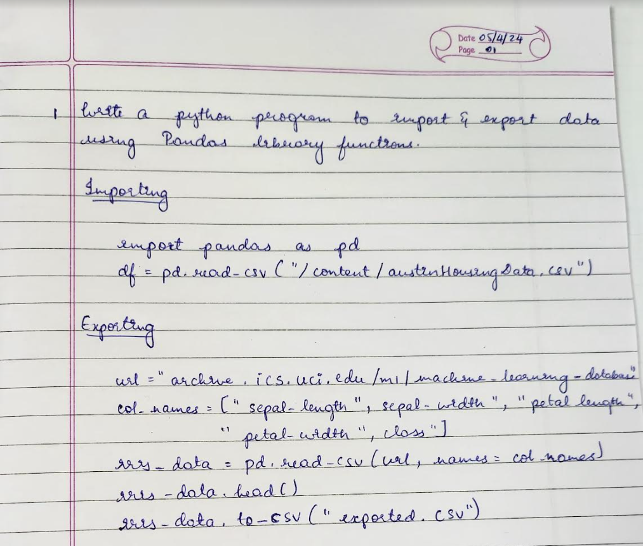

Code :

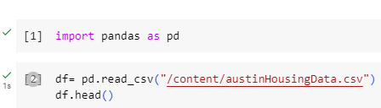

Output:

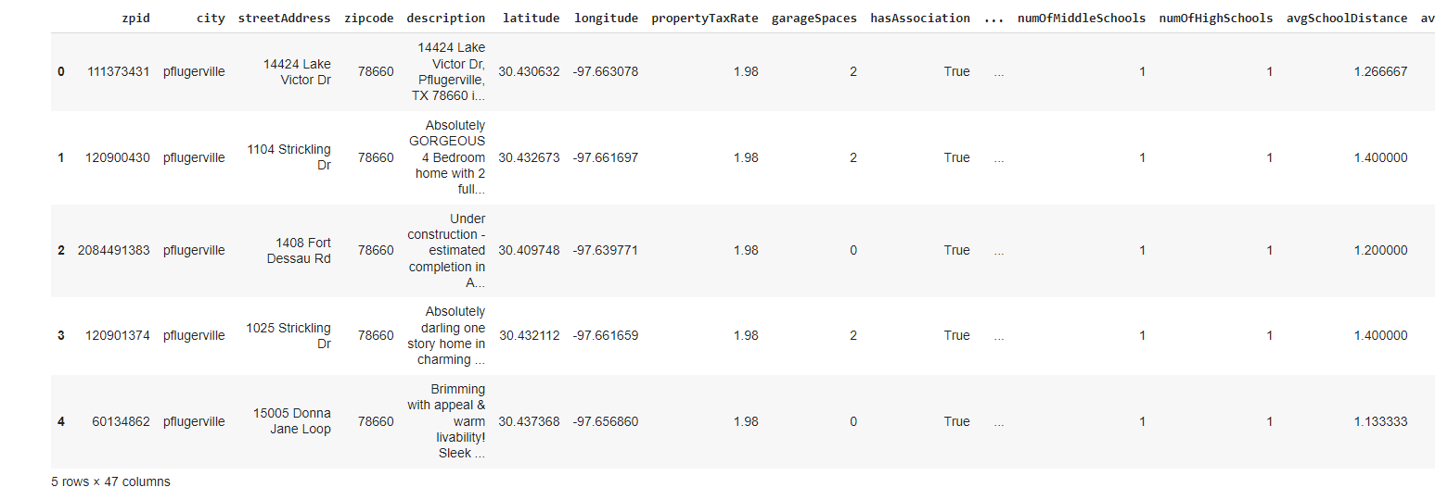

Code :

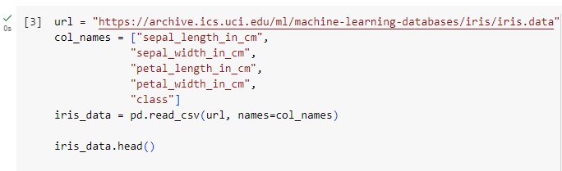

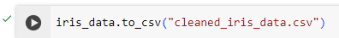

Output:

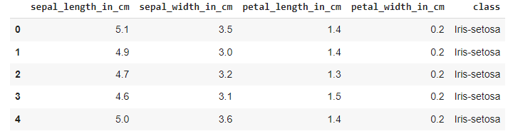

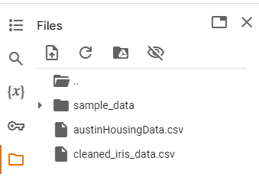

**Observation and report**

Date: 05/04/2024

Program Title:  Demonstrate various data pre-processing techniques for a given dataset.

Algorithm - snapshot from observation

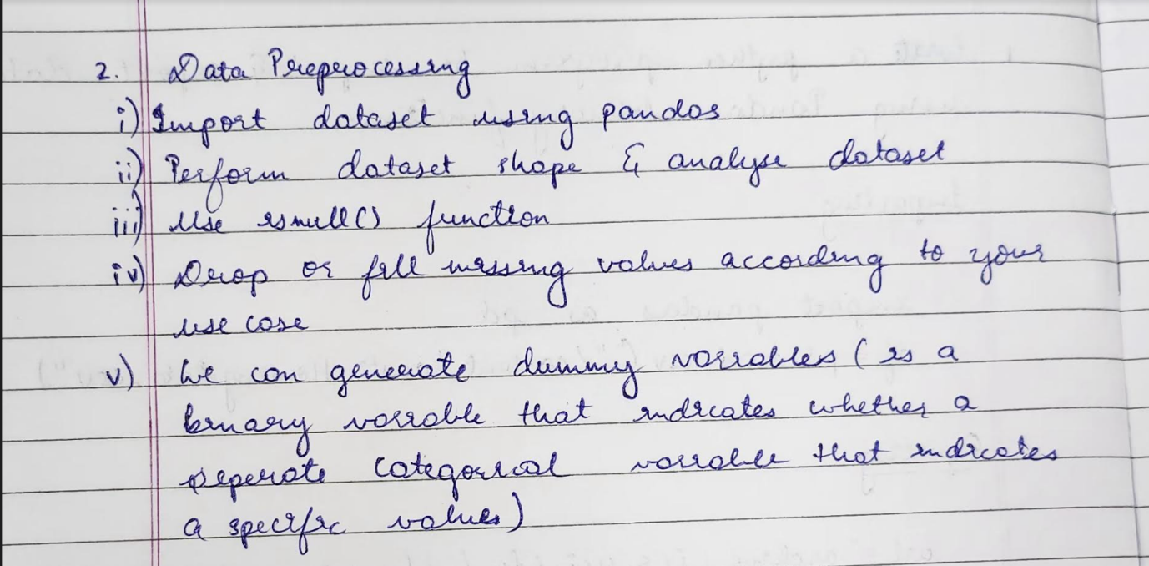

Code & Output:

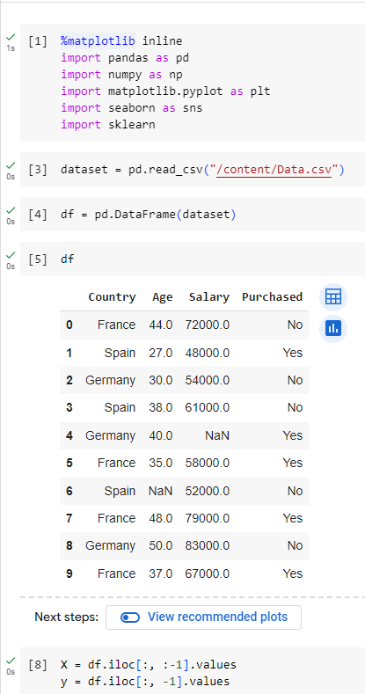

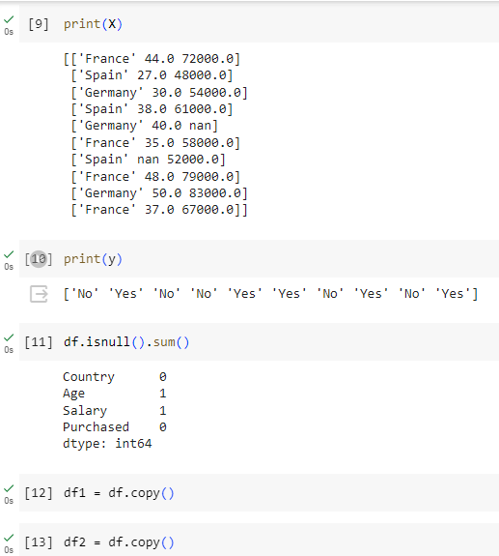

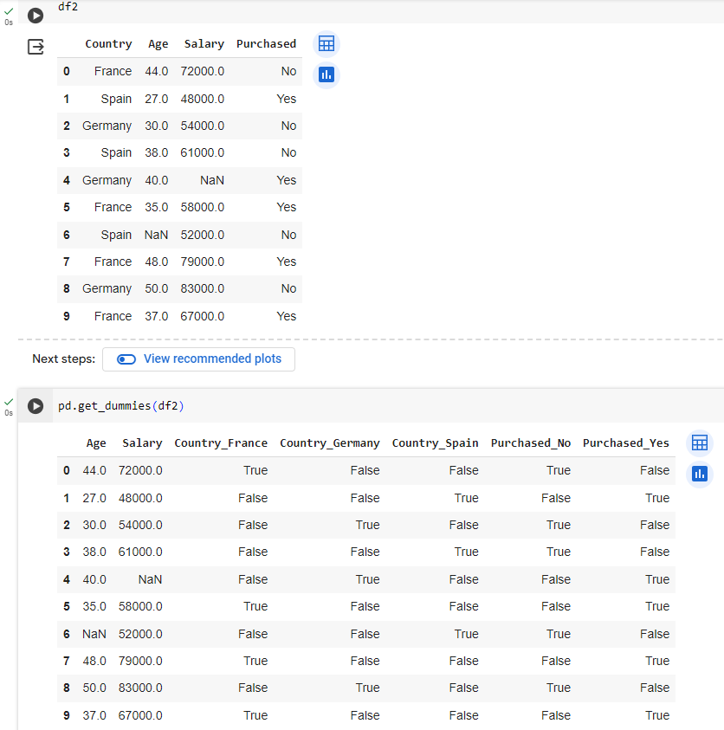

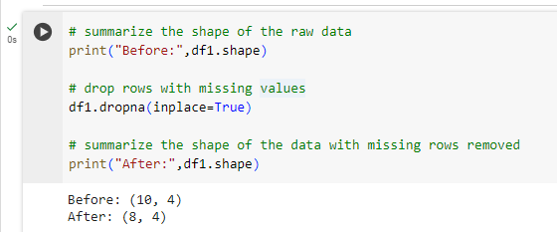

**Observation and report**

Date: 12/04/2024

Program Title: Write a python program for decision tree algorithm.

Algorithm - snapshot from observation

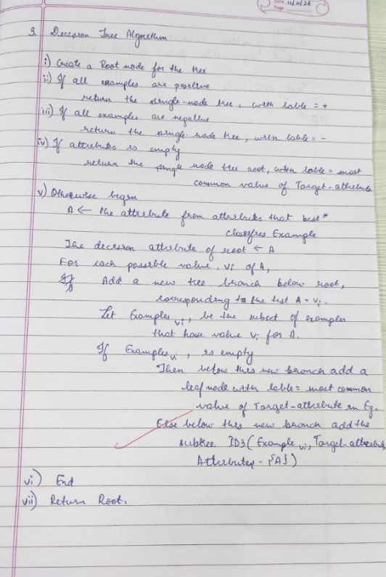

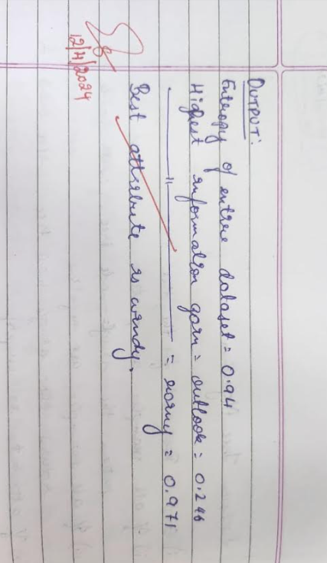

Code&Output :

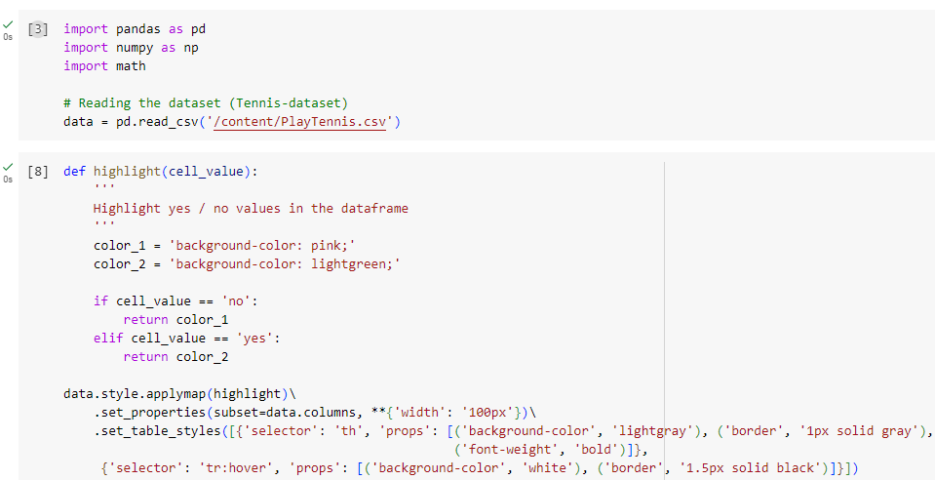

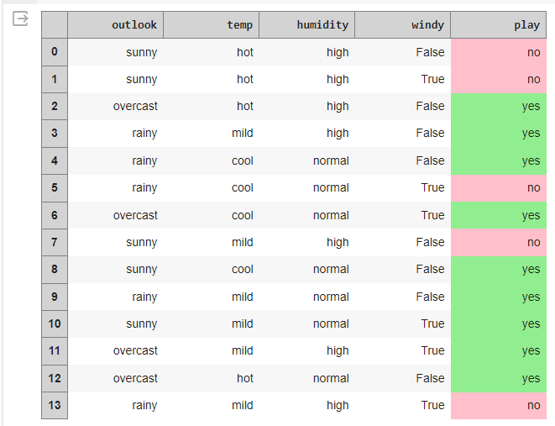

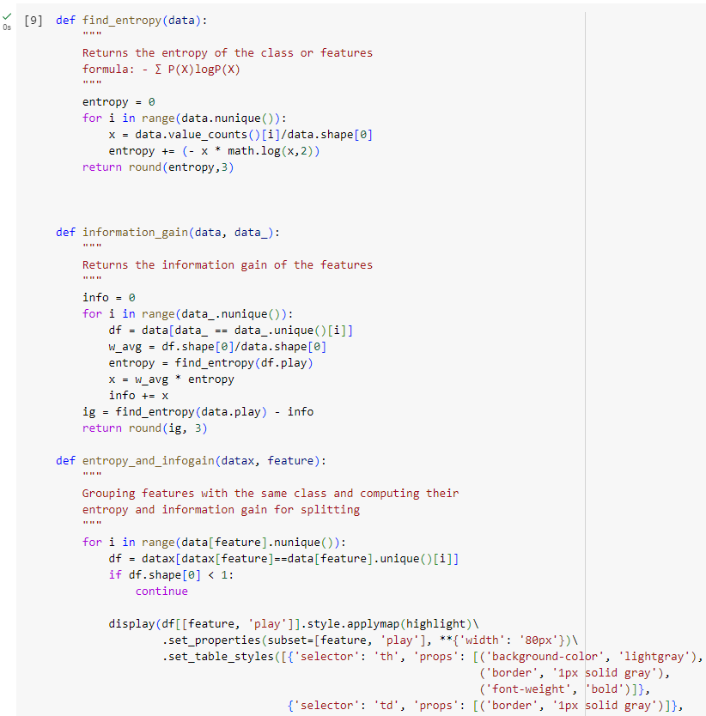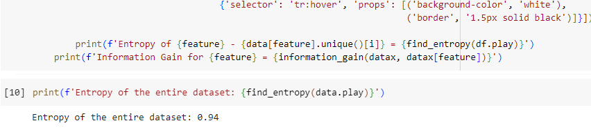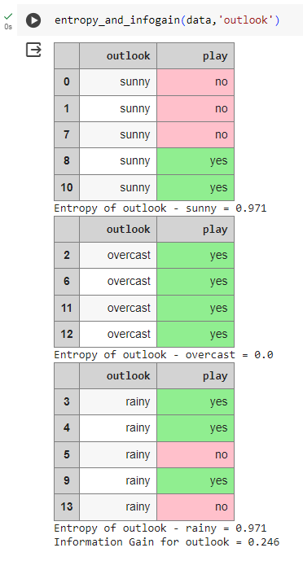

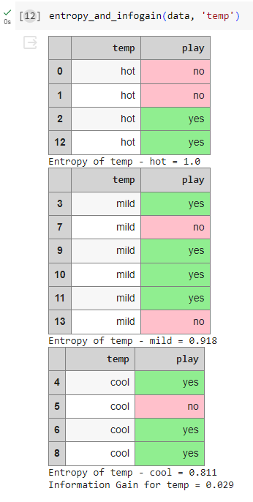

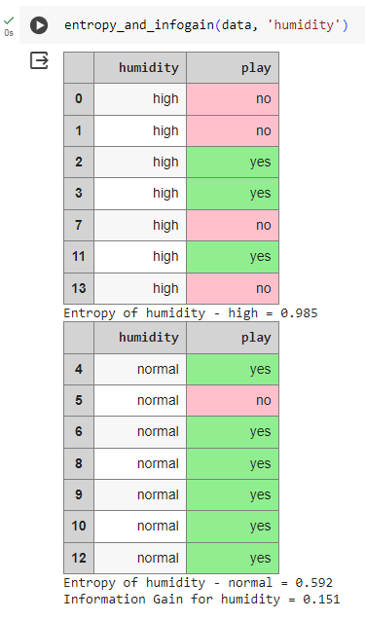

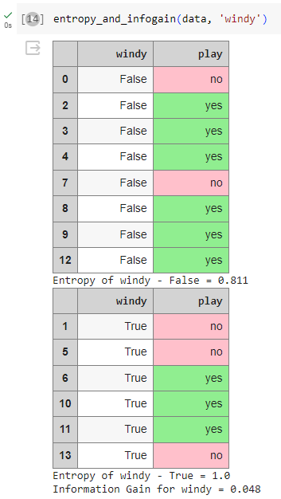

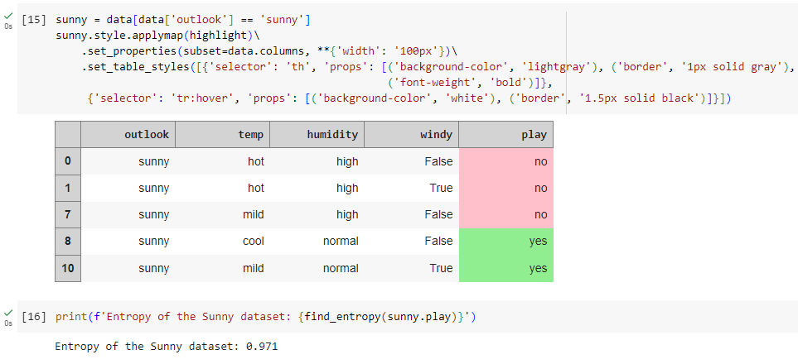

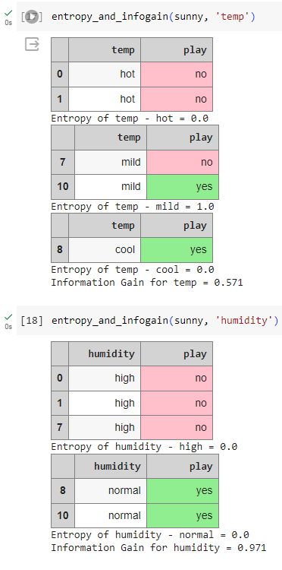

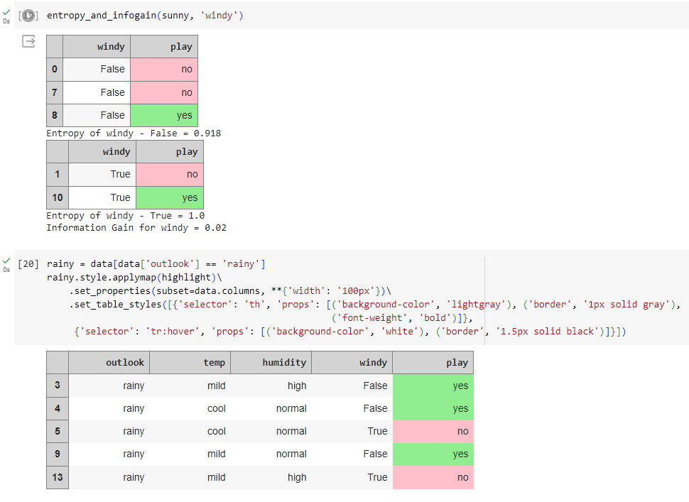

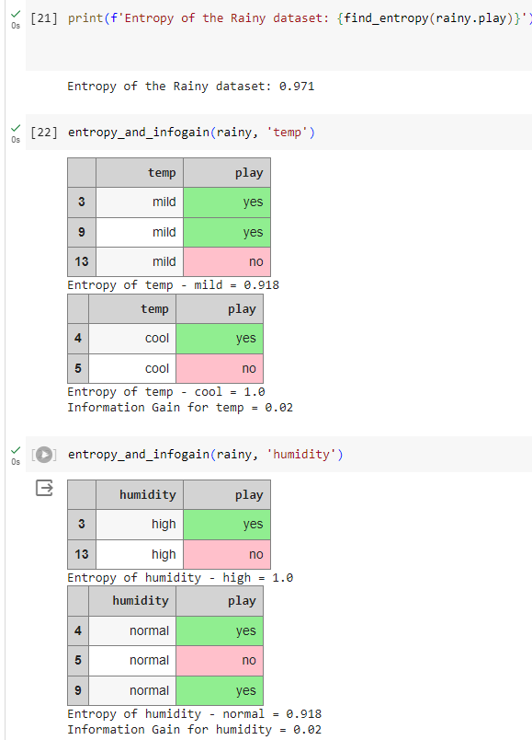

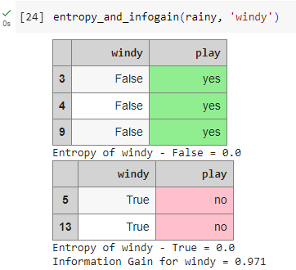

**Observation and report**

Date: 03/05/2024

Program Title: Build KNN Classification model for a given dataset.

Algorithm - snapshot from observation

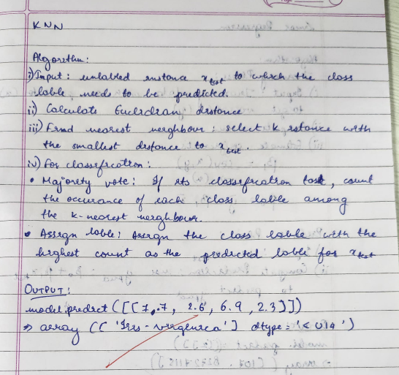

Code&Output :

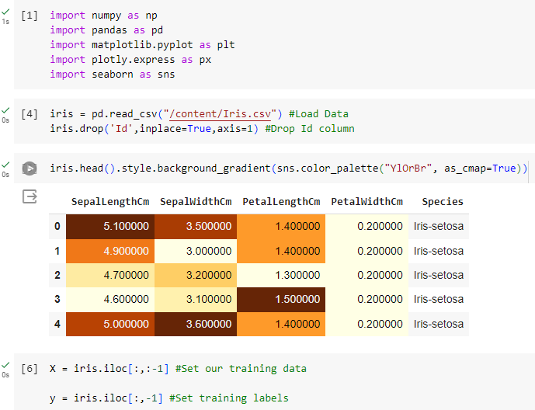

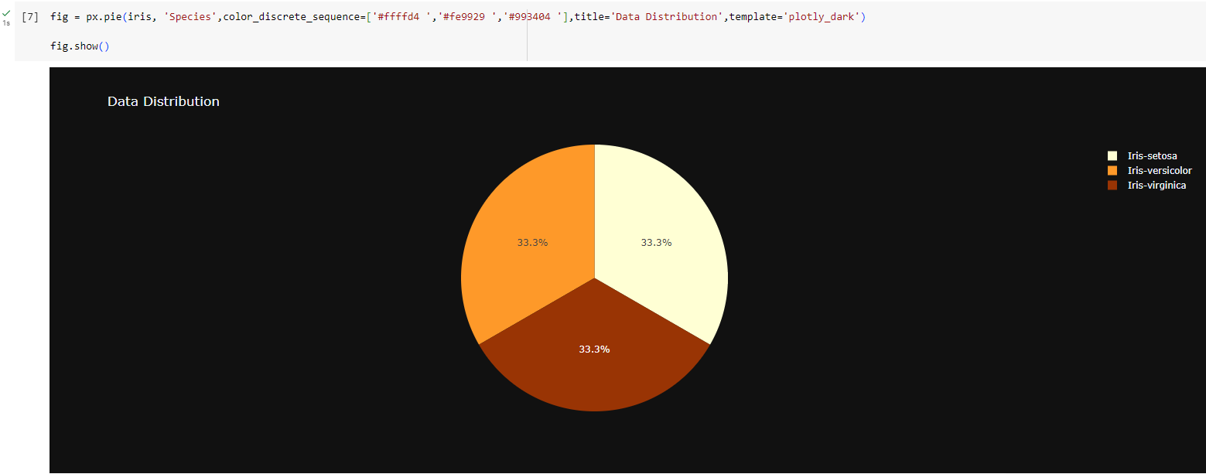

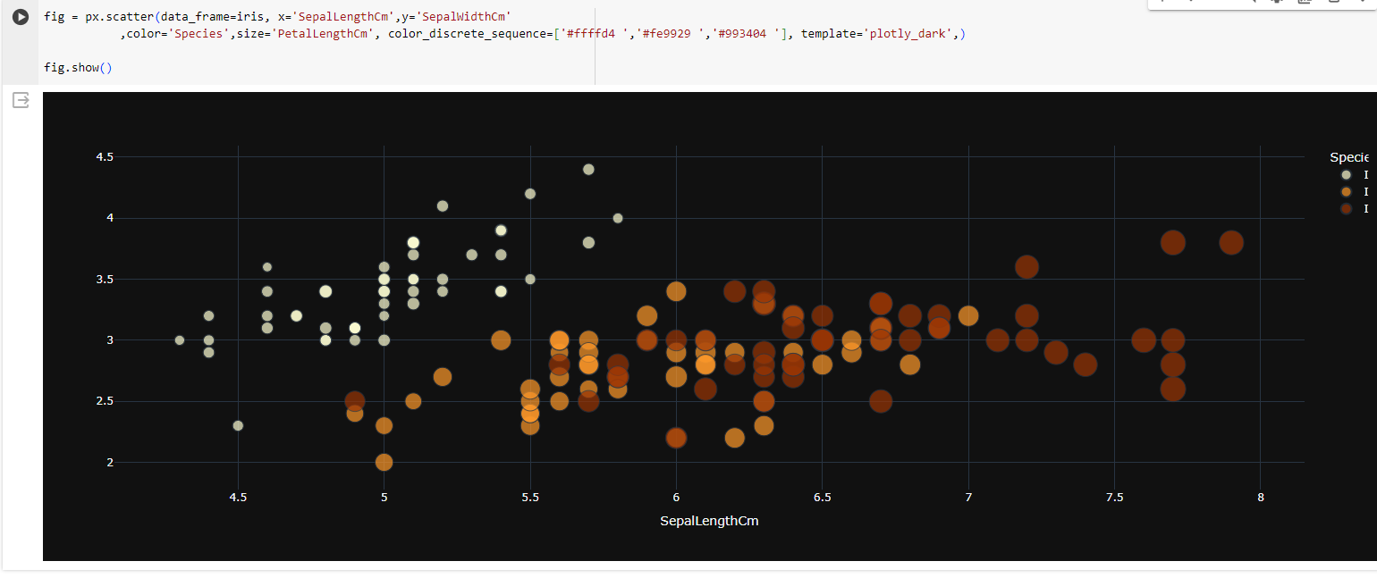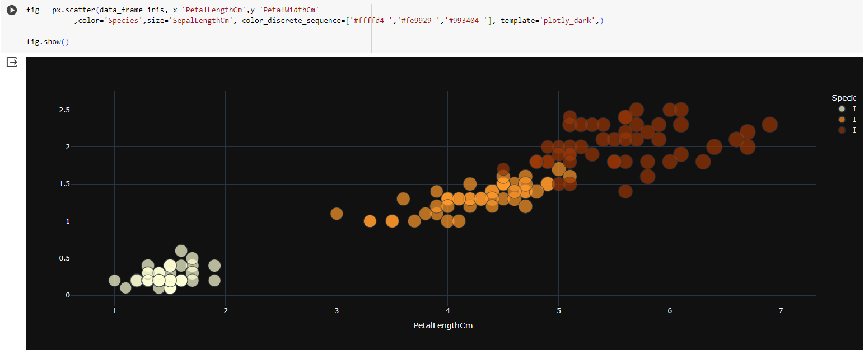

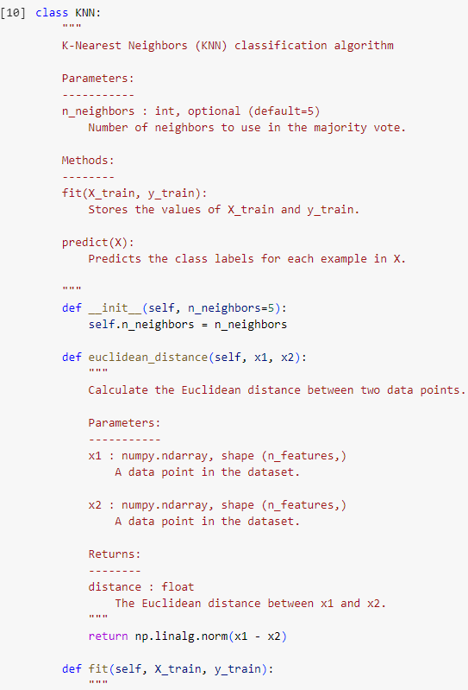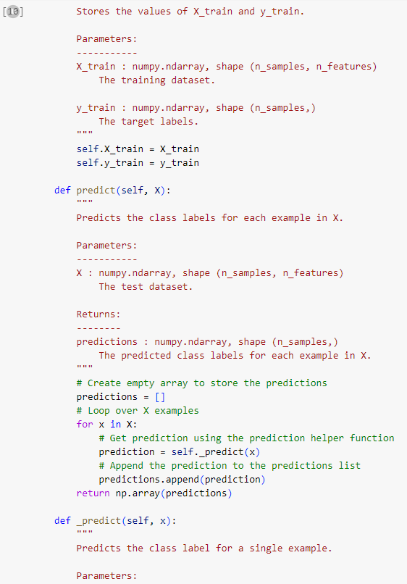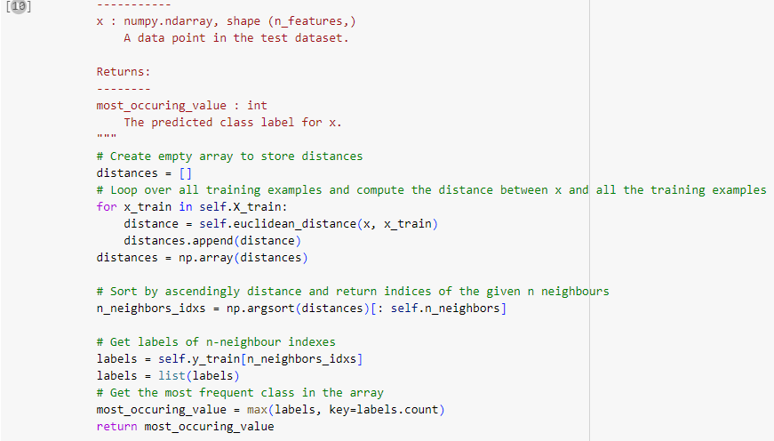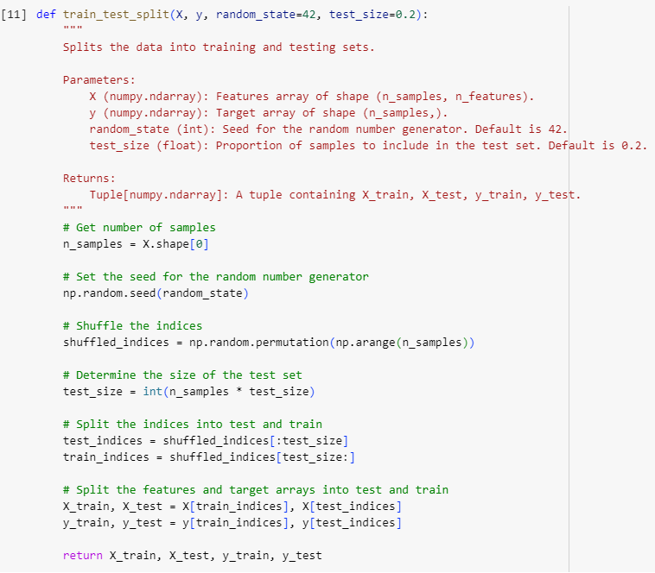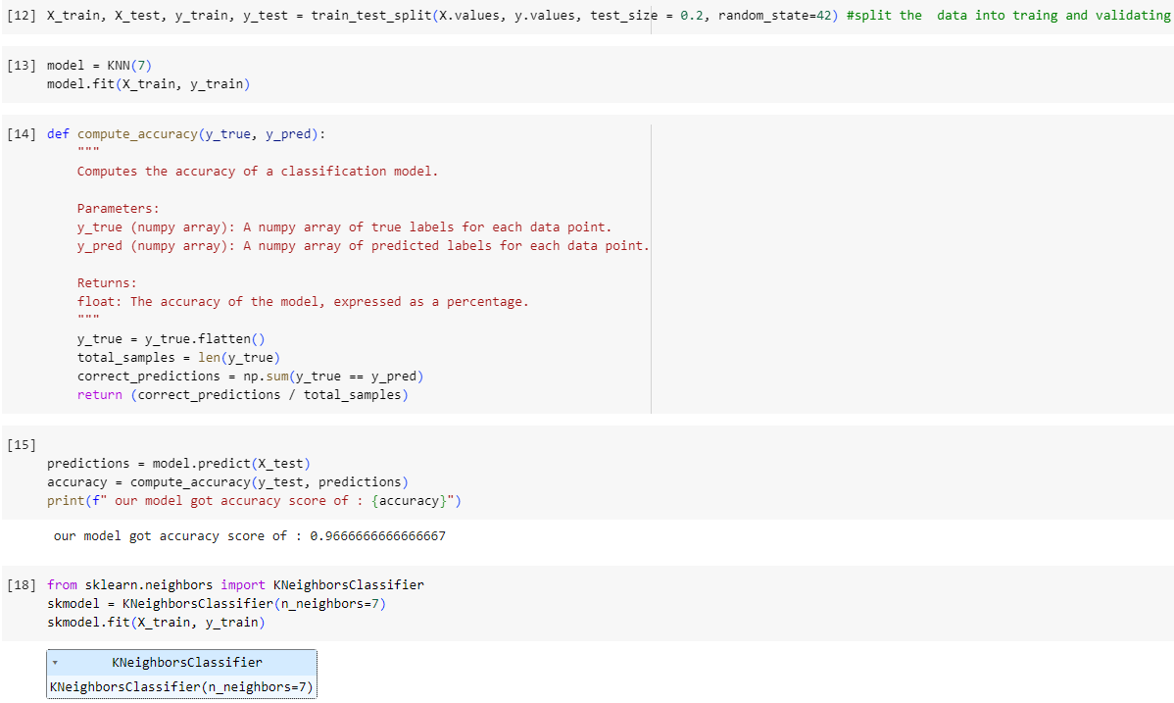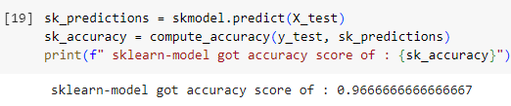

**Observation and report**

Date: 03/05/2024

Program Title:  Implement Linear Regression algorithm using appropriate dataset

Algorithm - snapshot from observation

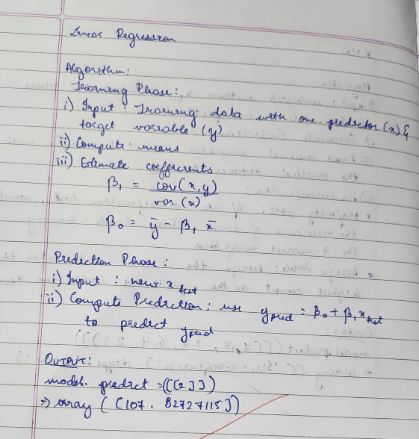

Code & Output:

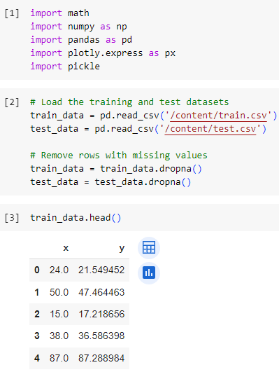

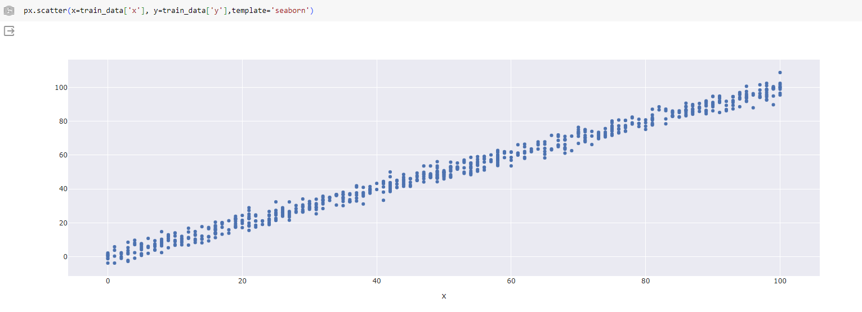

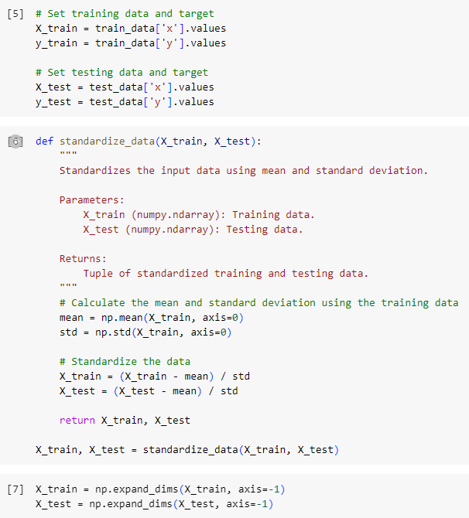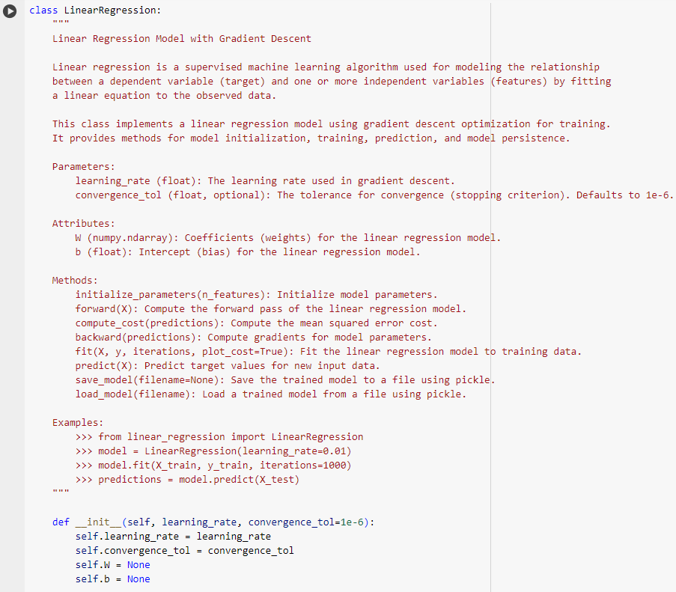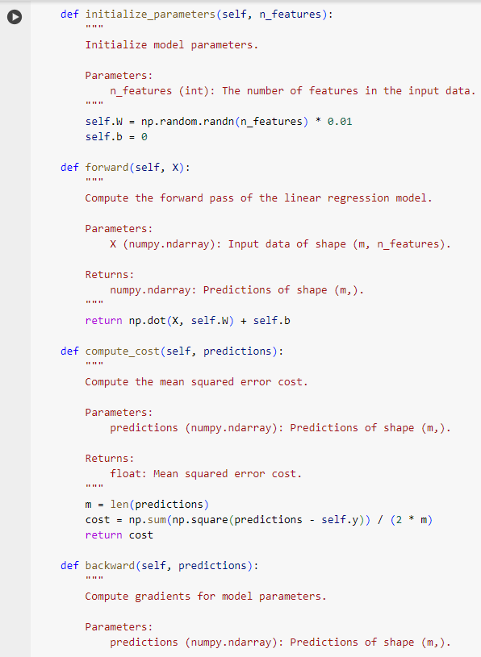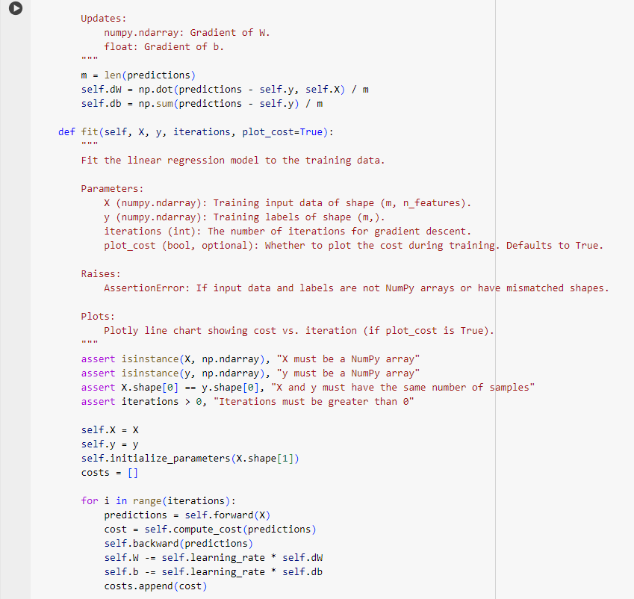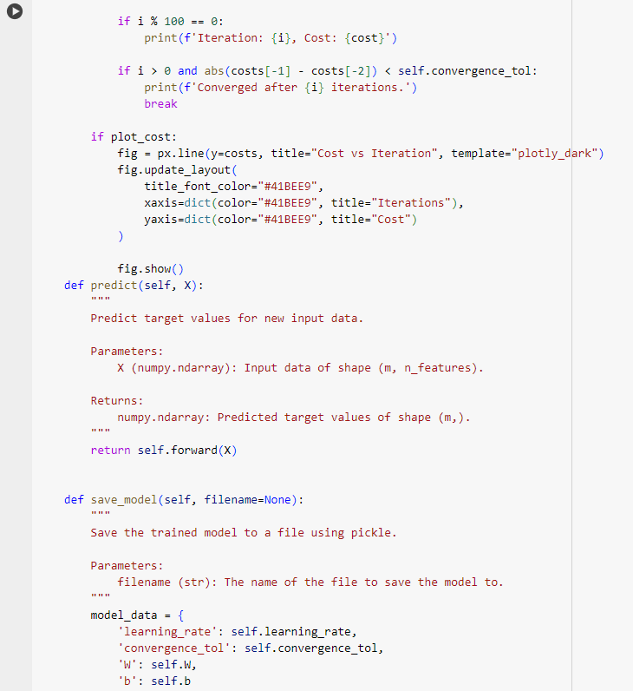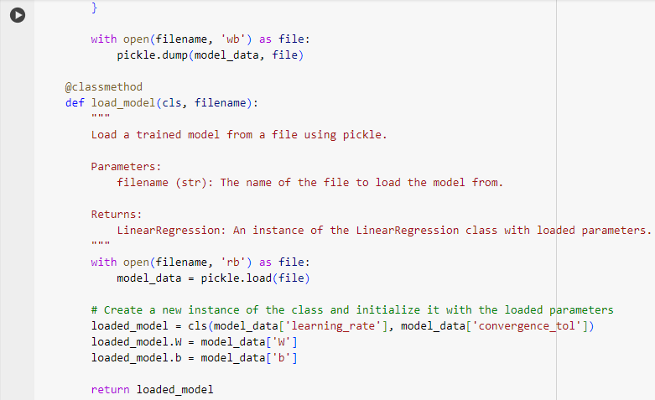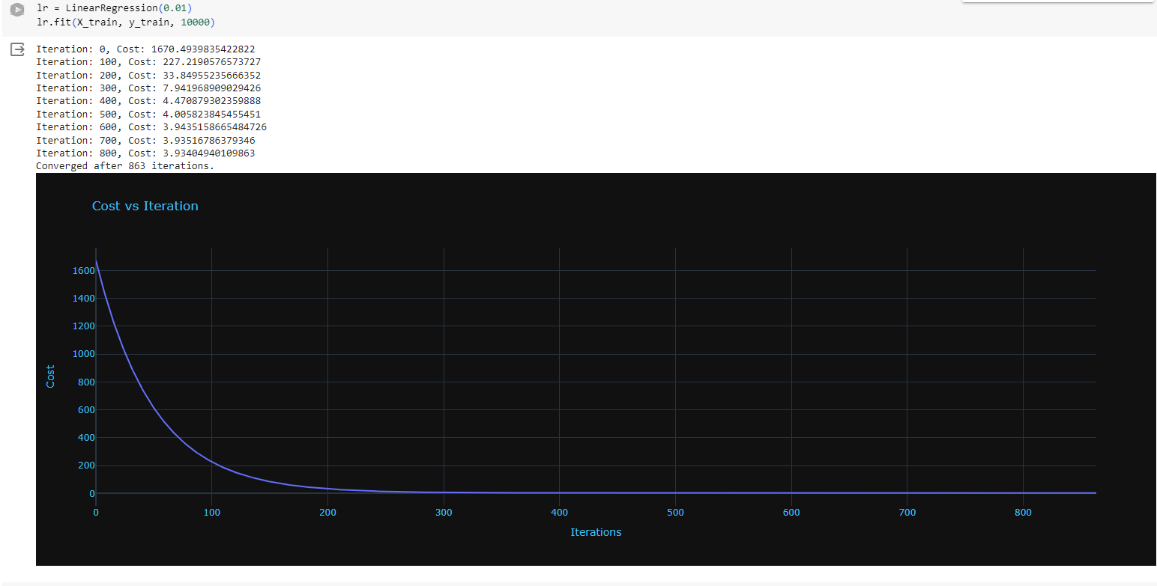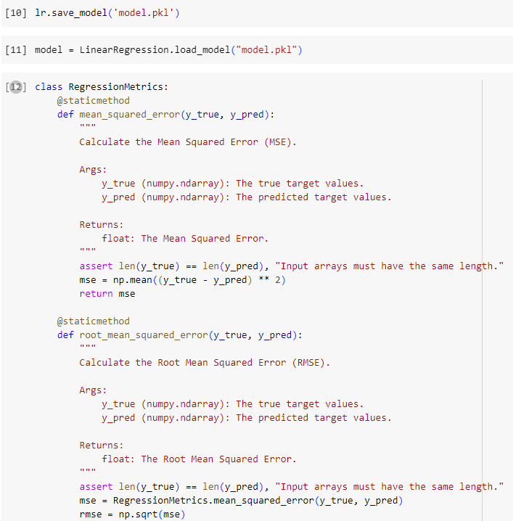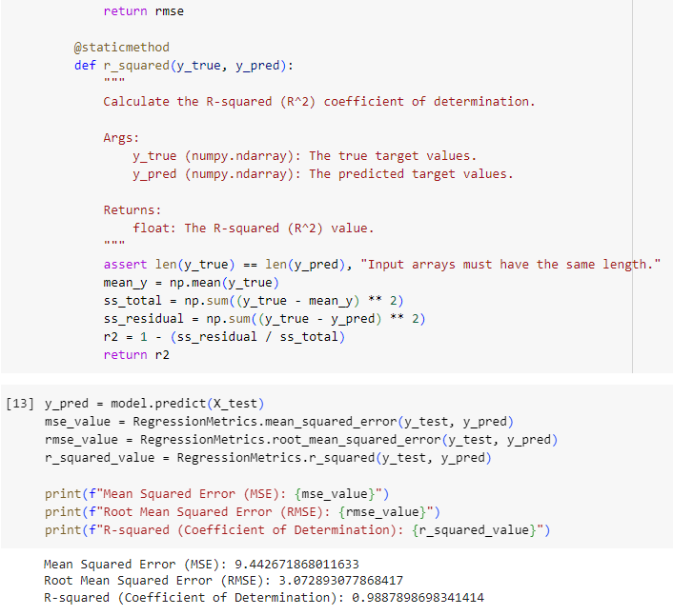

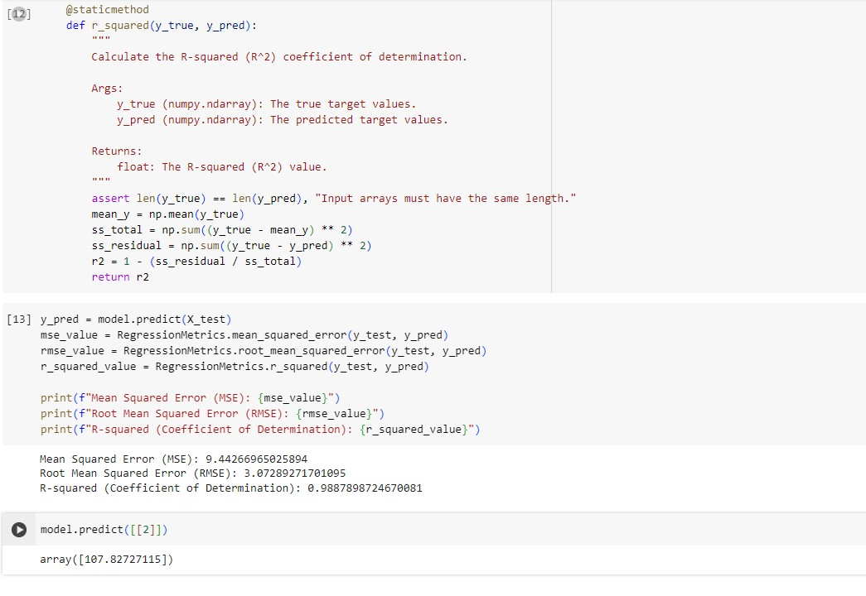

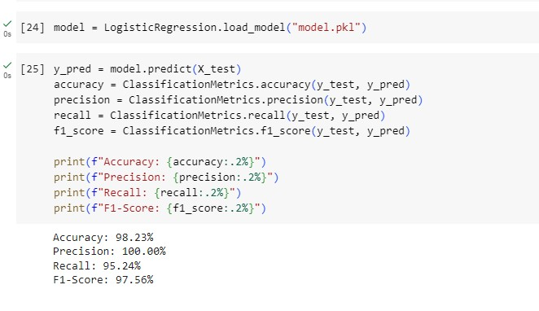

**Observation and report**

Date: 03/05/2024

Program Title: Build Logistic Regression Model for a given dataset

Algorithm - snapshot from observation

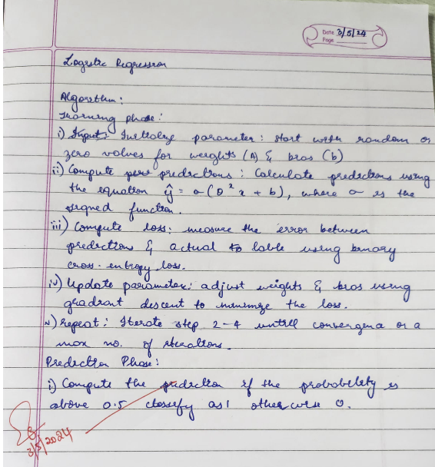

Code & Output:

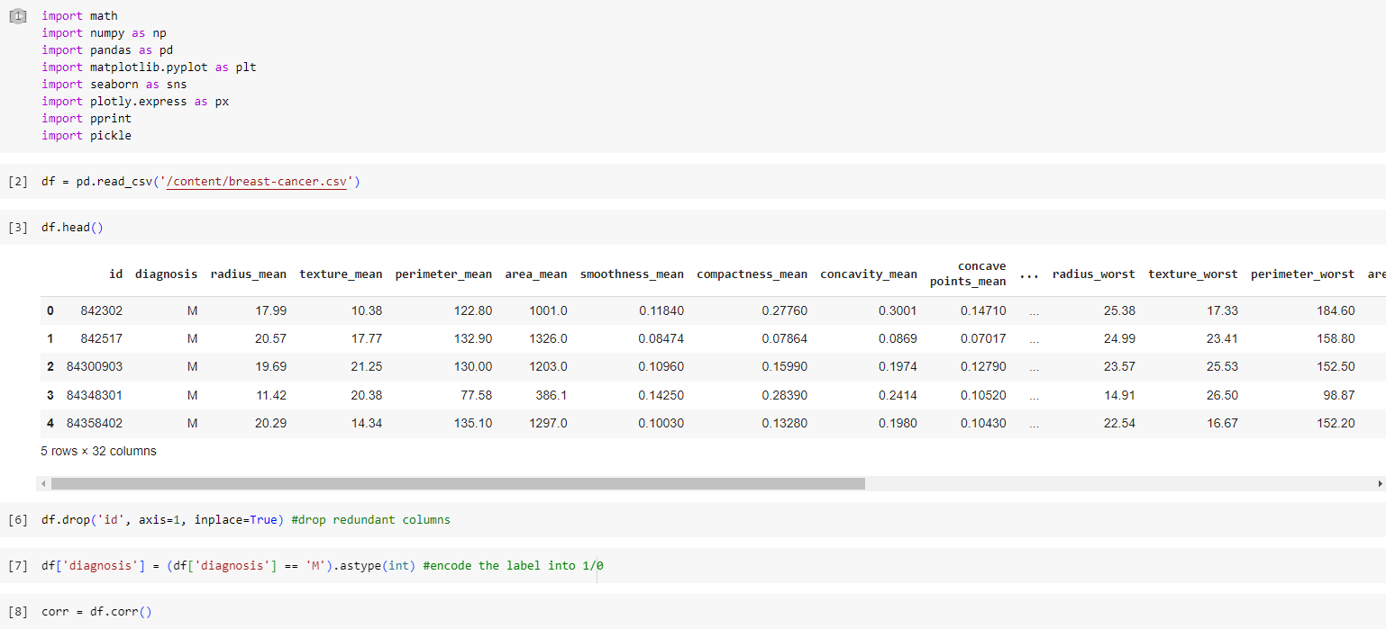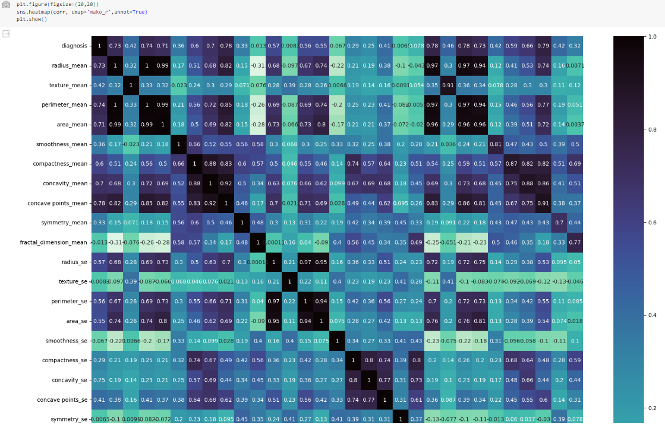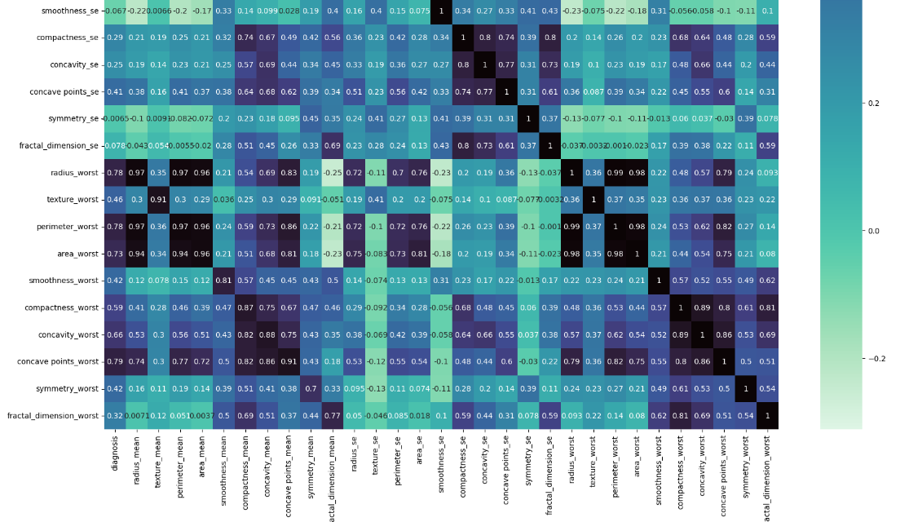

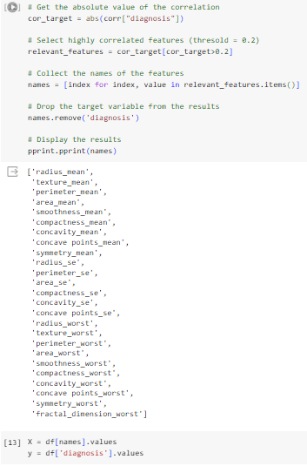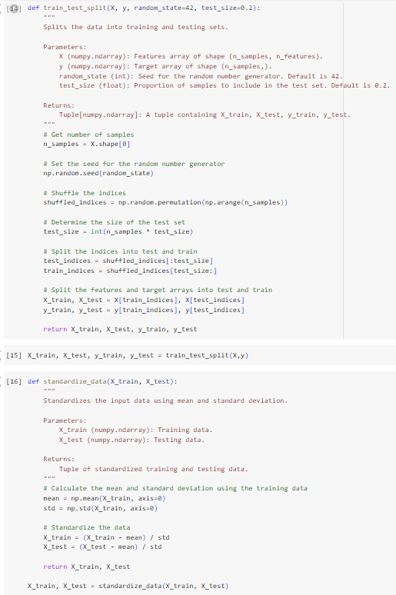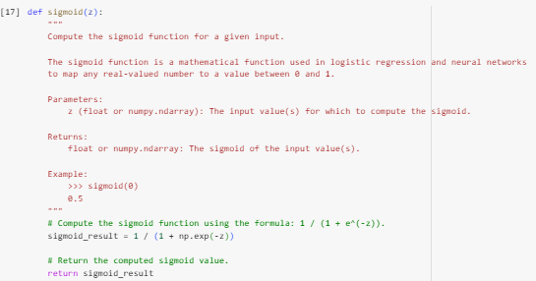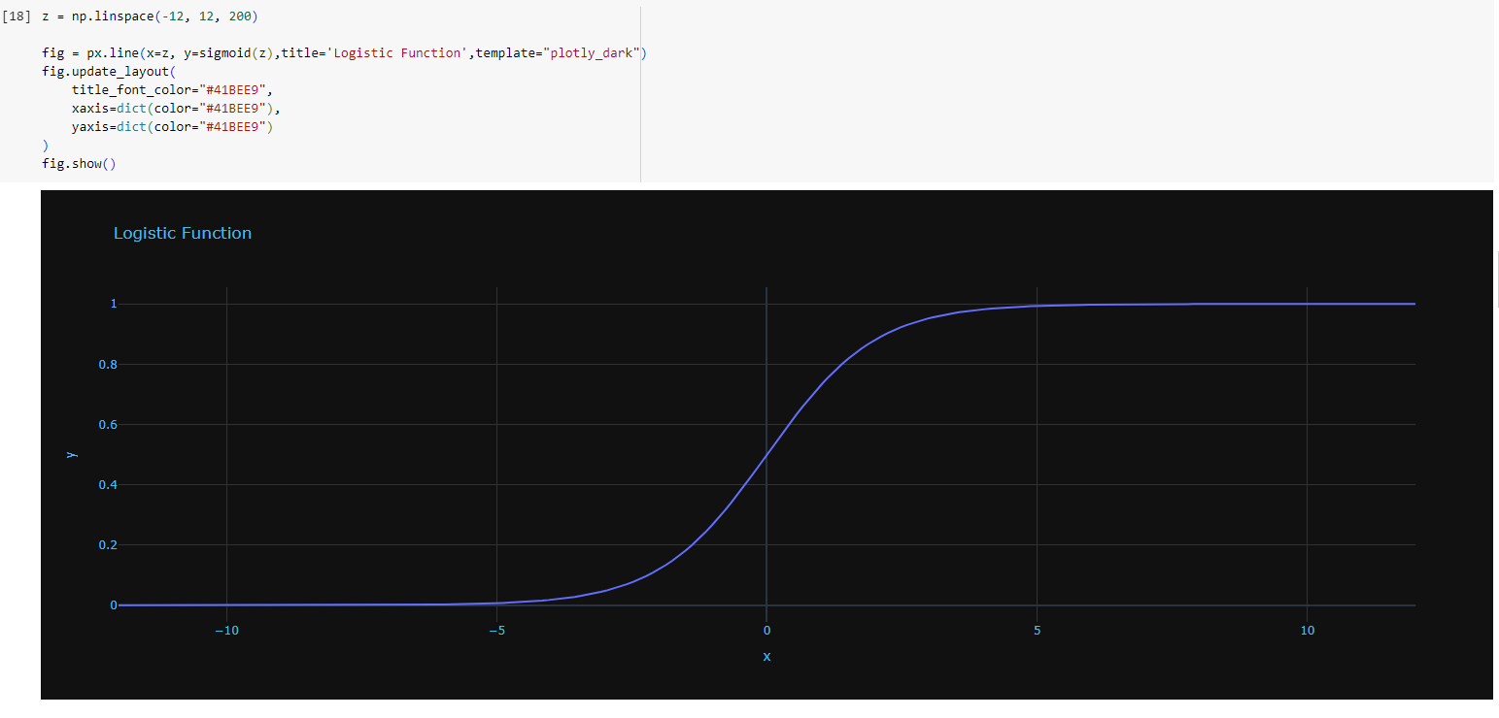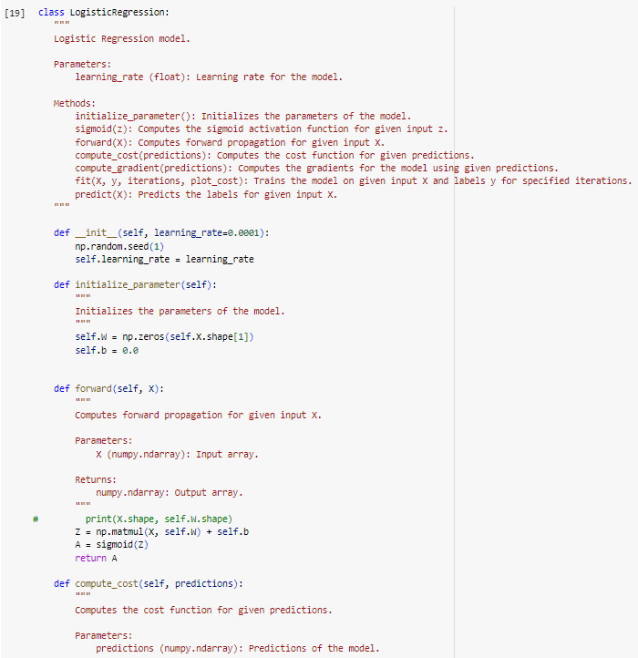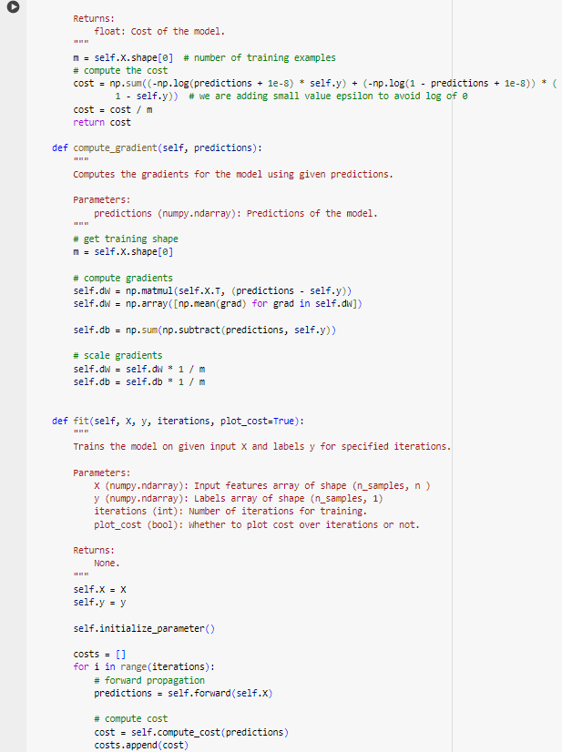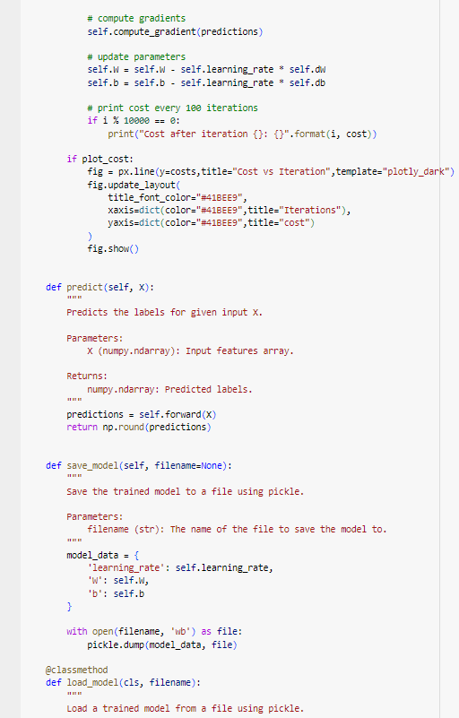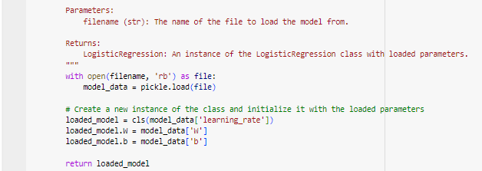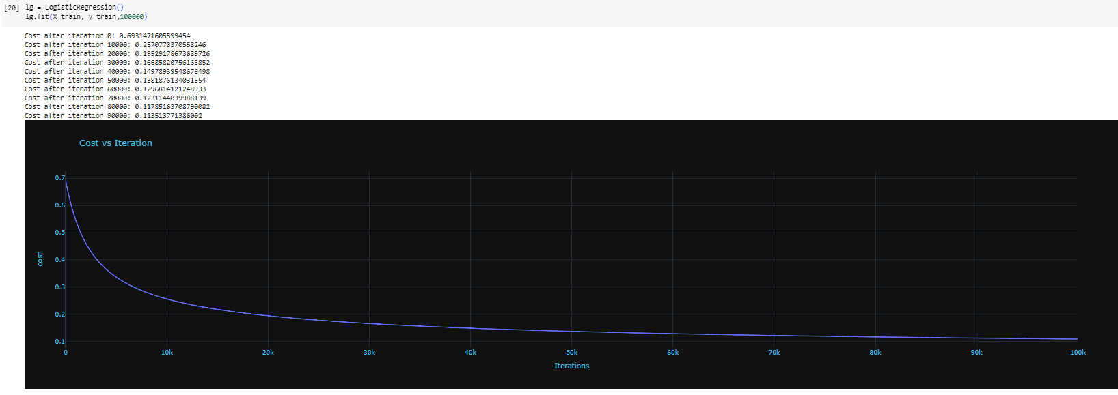

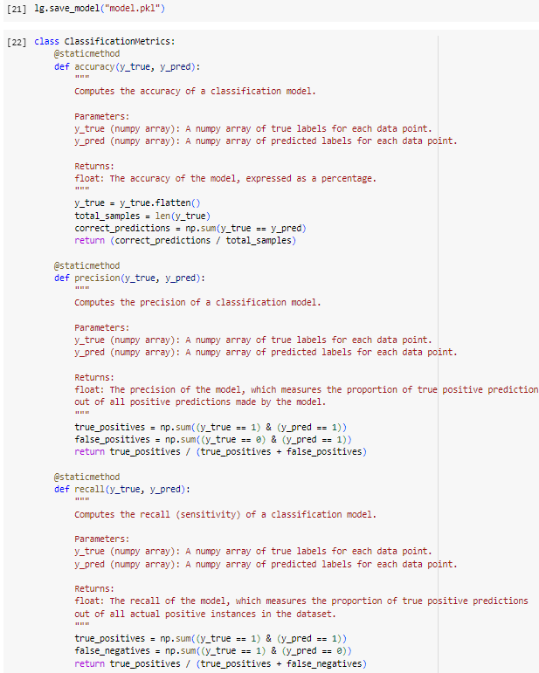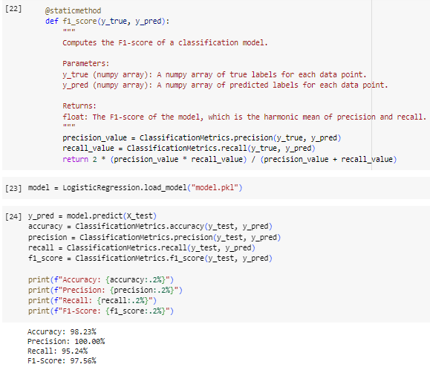

**Observation and report**

Date: 24/05/2024

Program Title: Build Support vector machine model for a given dataset Algorithm

Algorithm - snapshot from observation

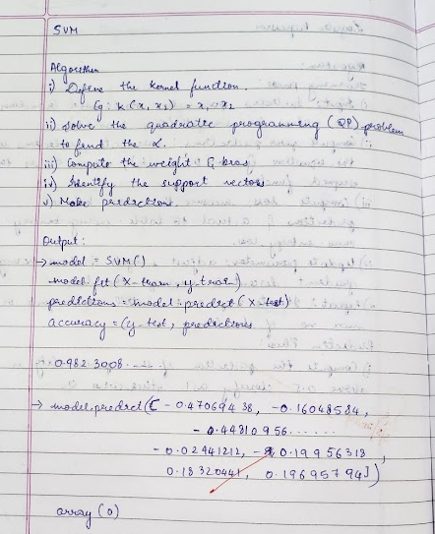

Code & Output:

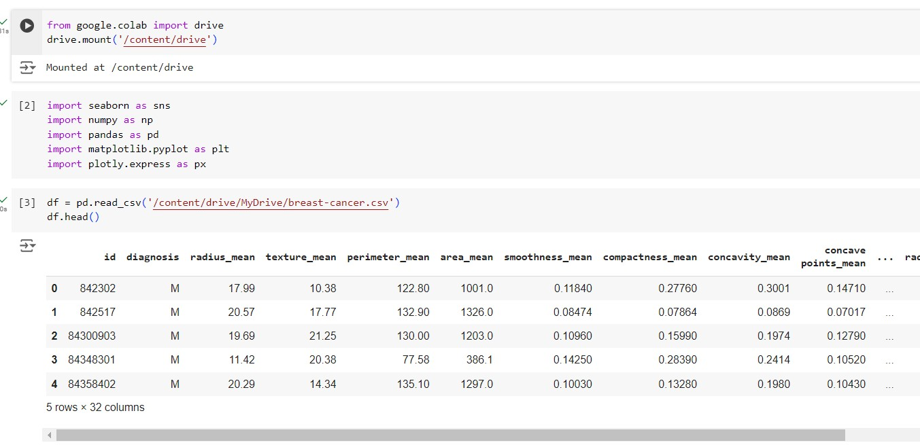

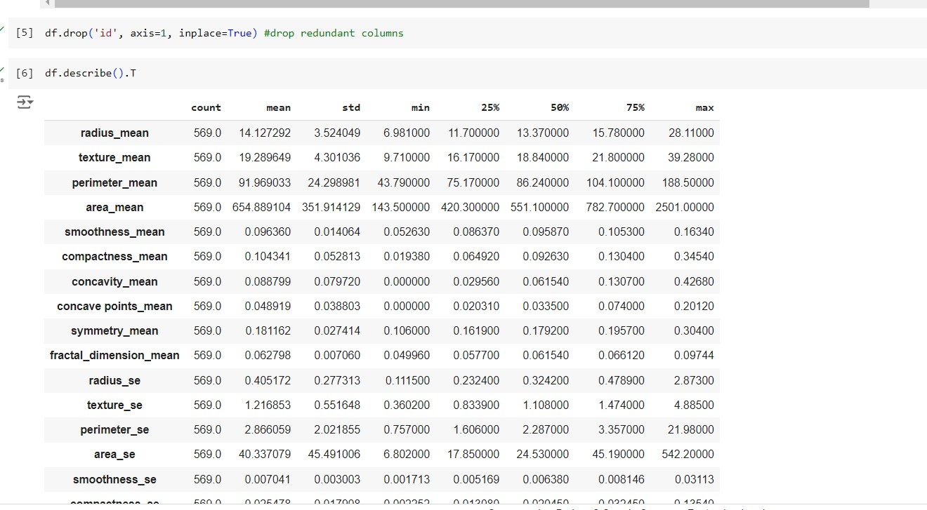

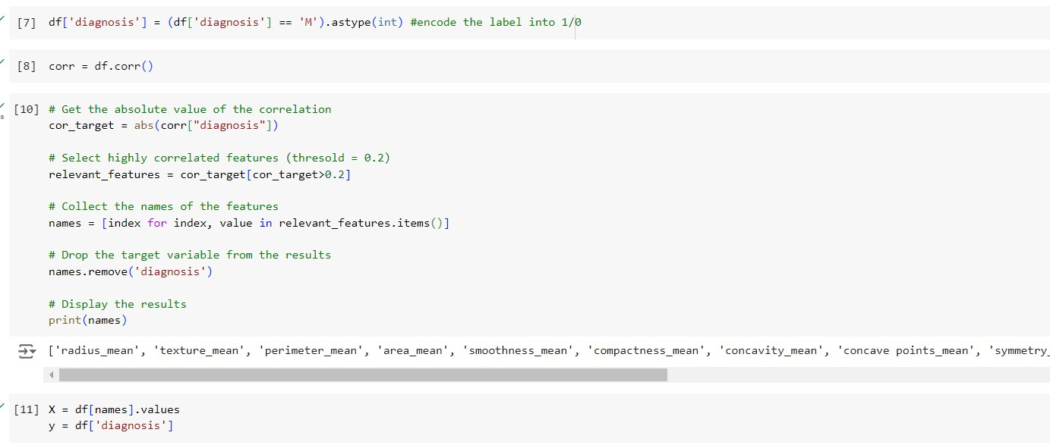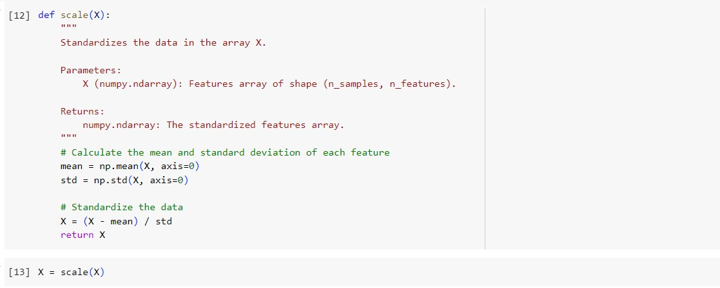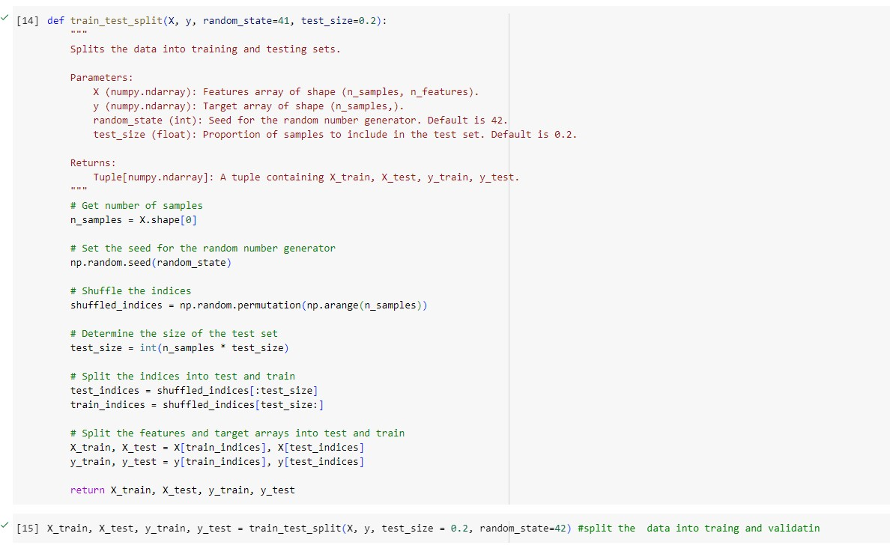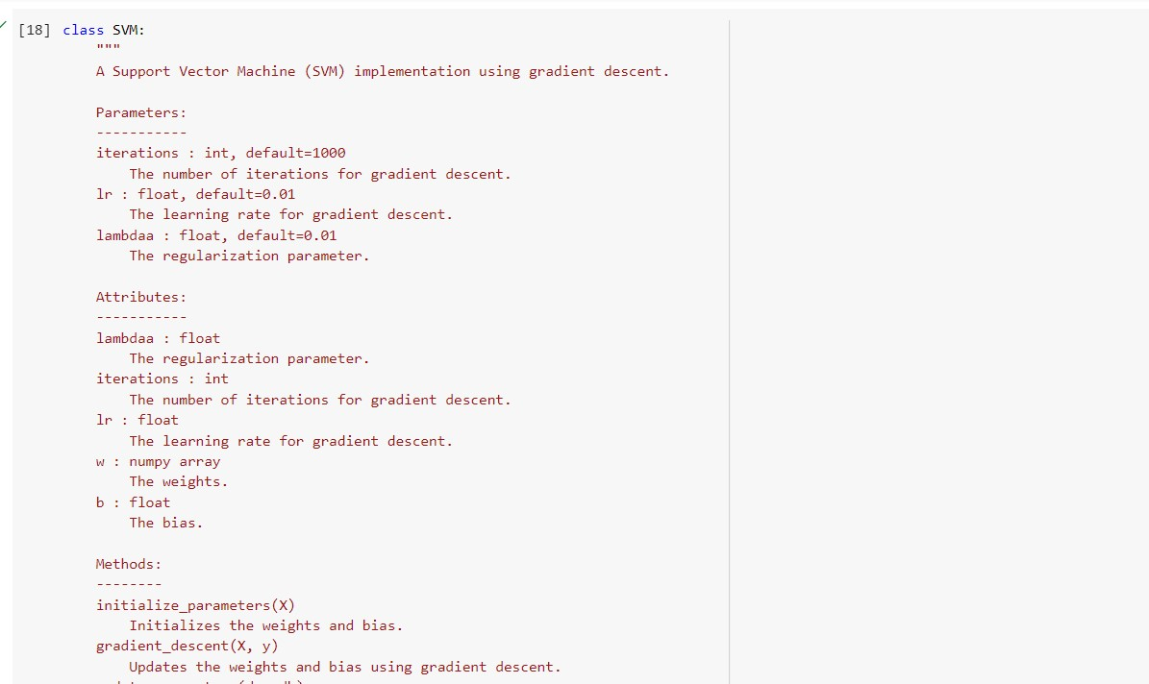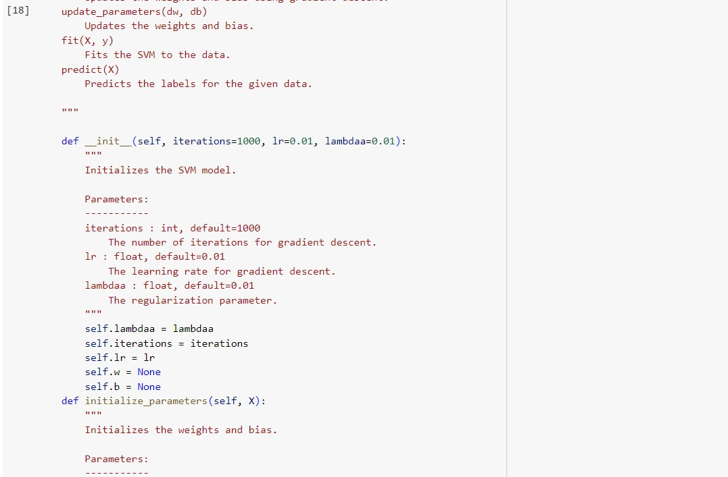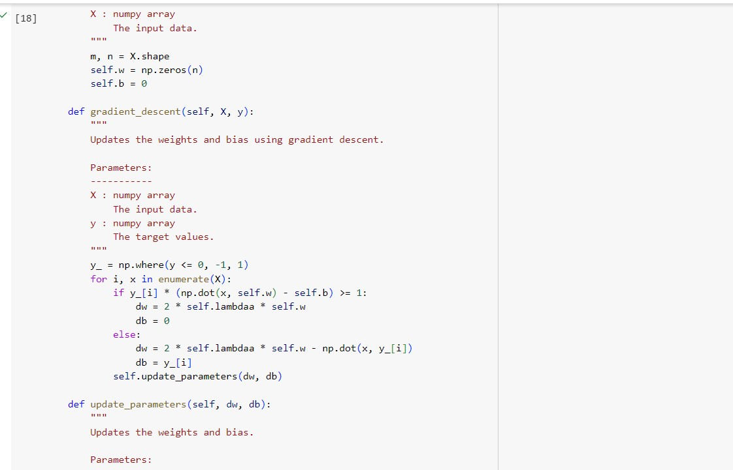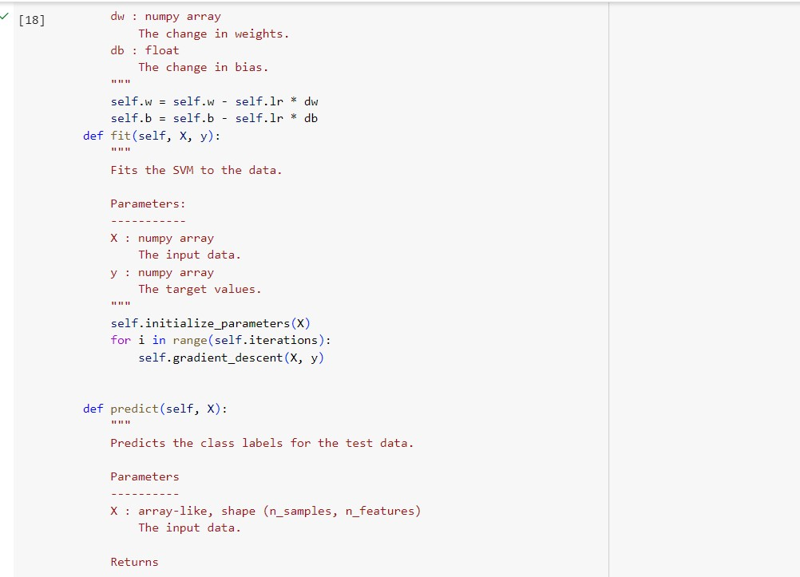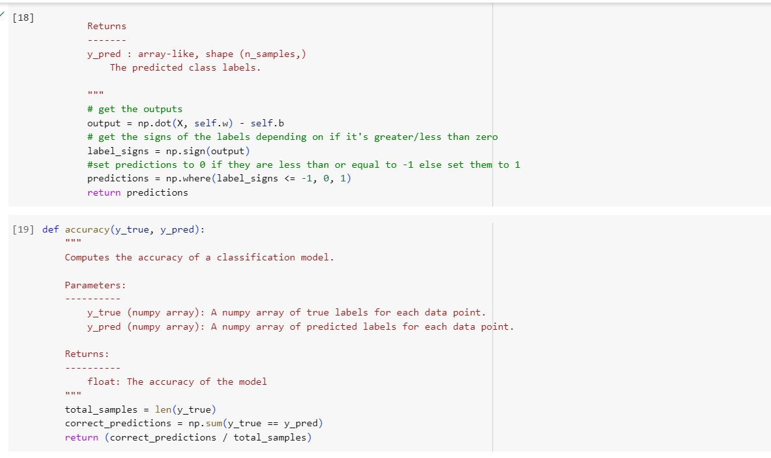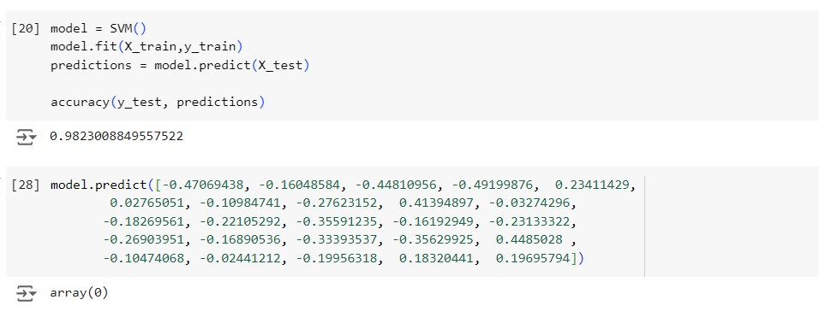

**Observation and report**

Date: 24/05/2024

Program Title: Build k-Means algorithm to cluster a set of data stored in a .CSV file

Algorithm - snapshot from observation

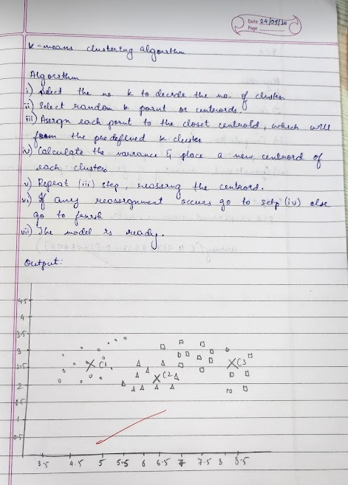

Code & Output:

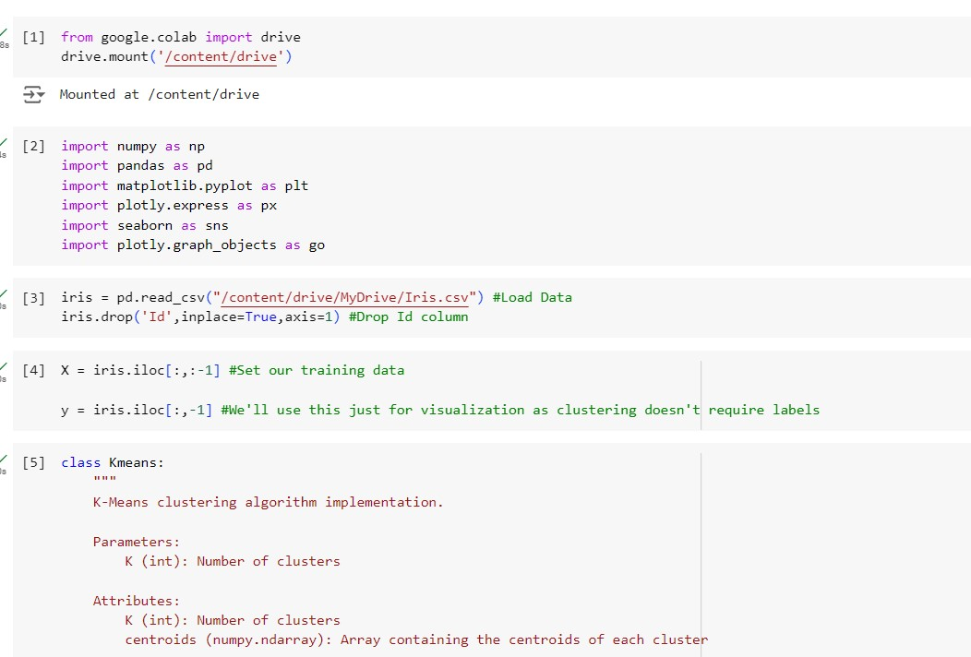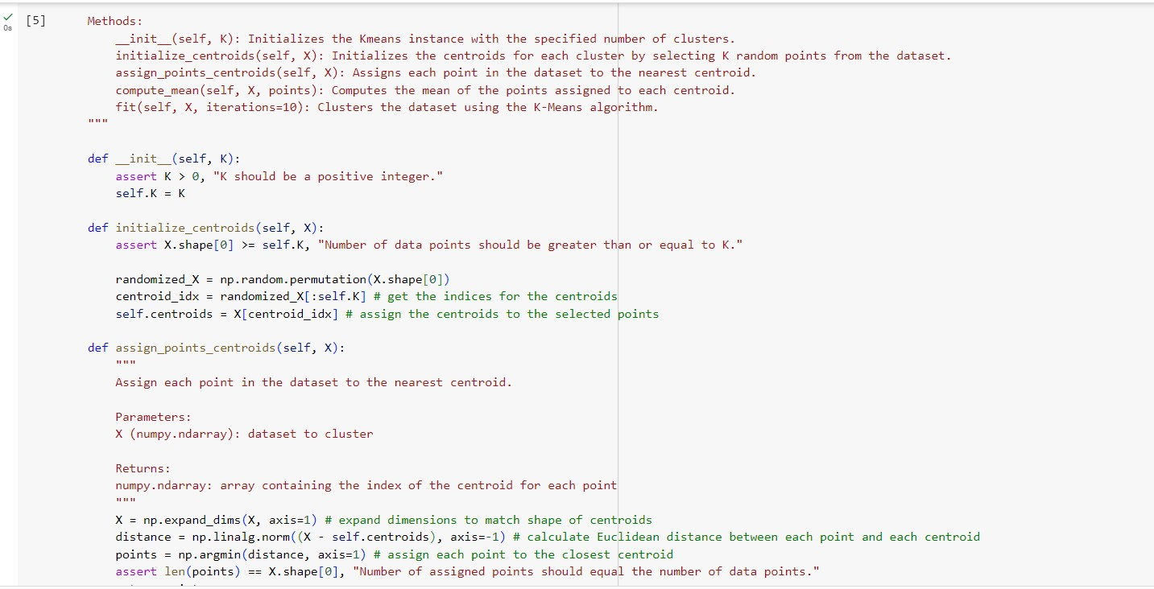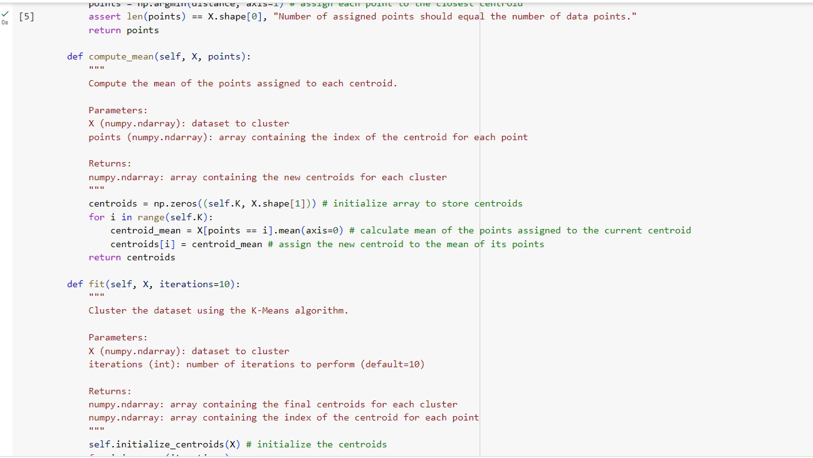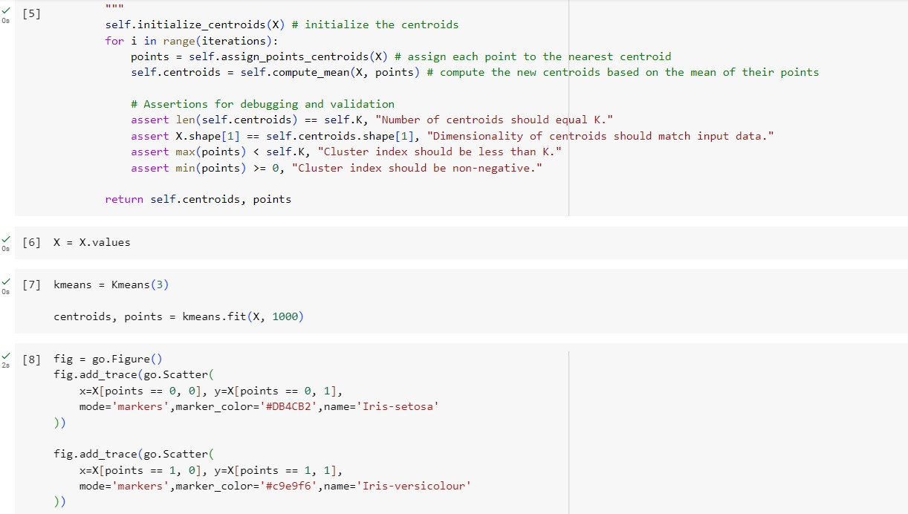

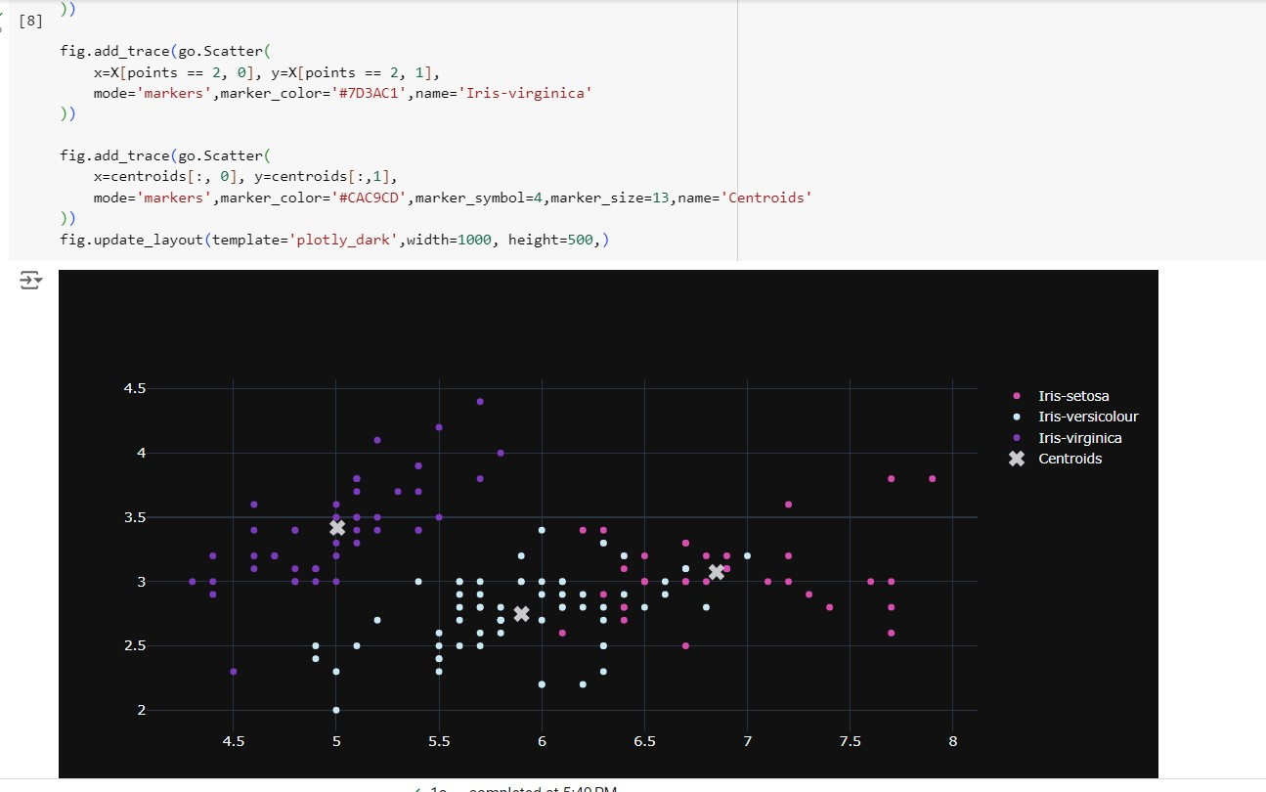

**Observation and report**

Date: 24/05/2024

Program Title: Implement Dimensionality reduction using Principle Component Analysis (PCA)

Algorithm - snapshot from observation

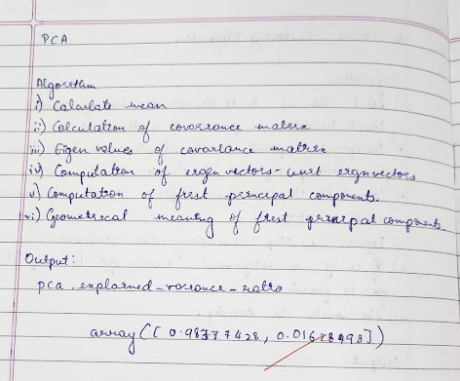

Code & Output:

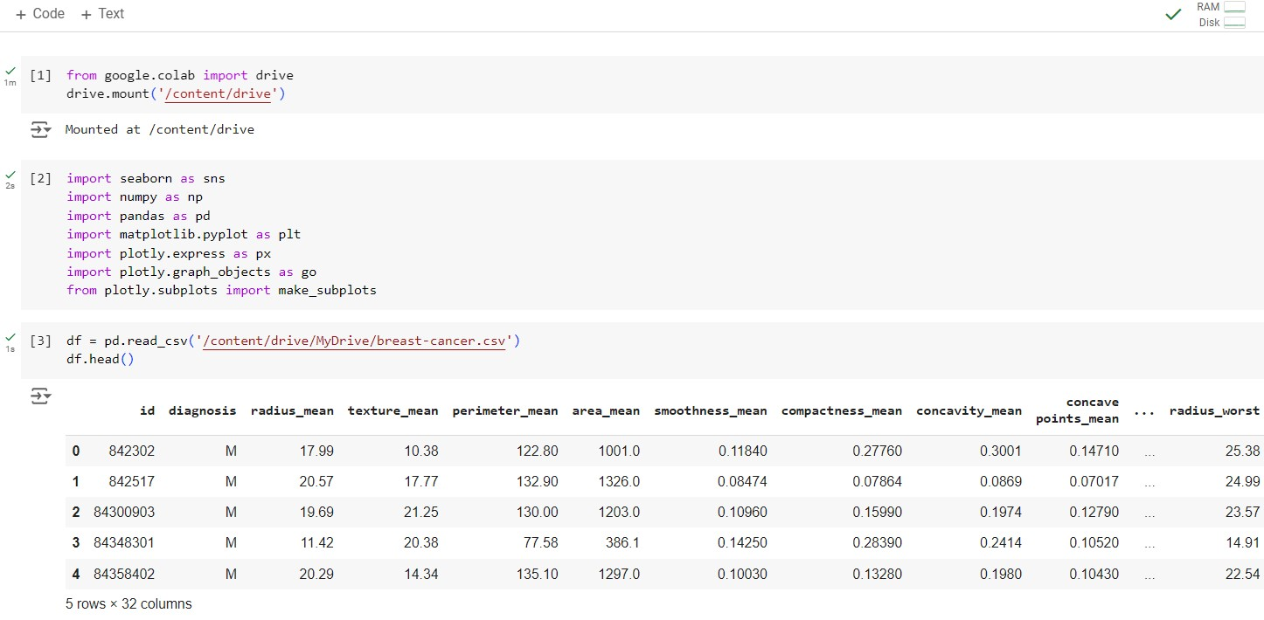

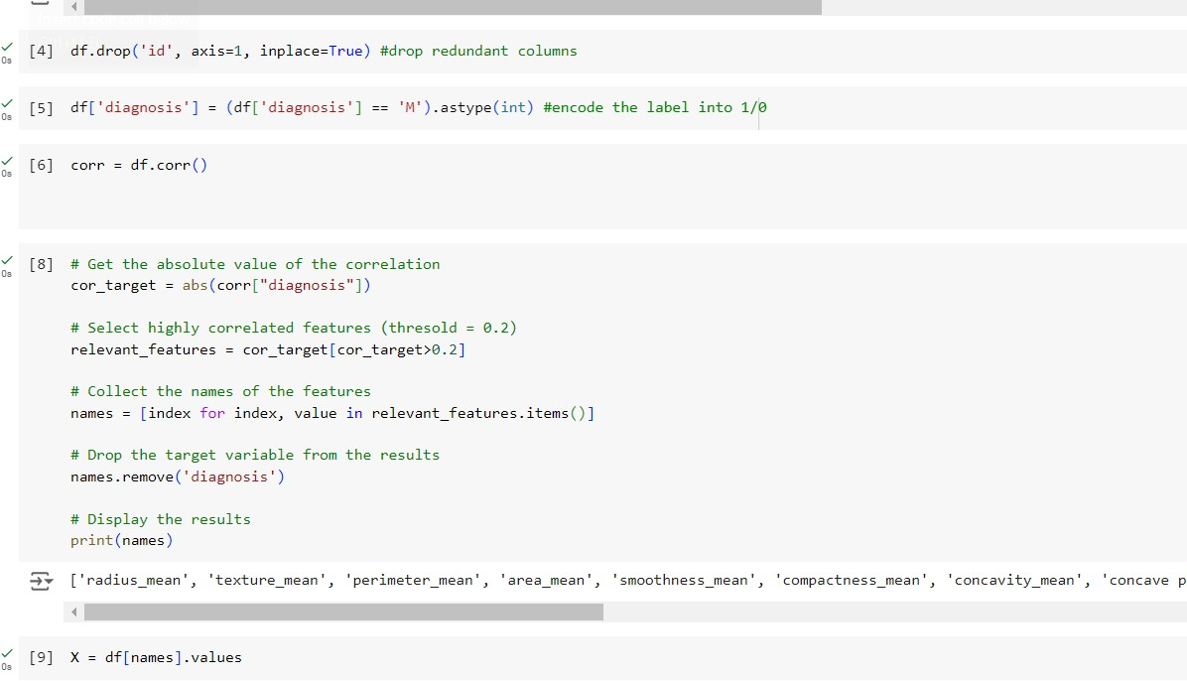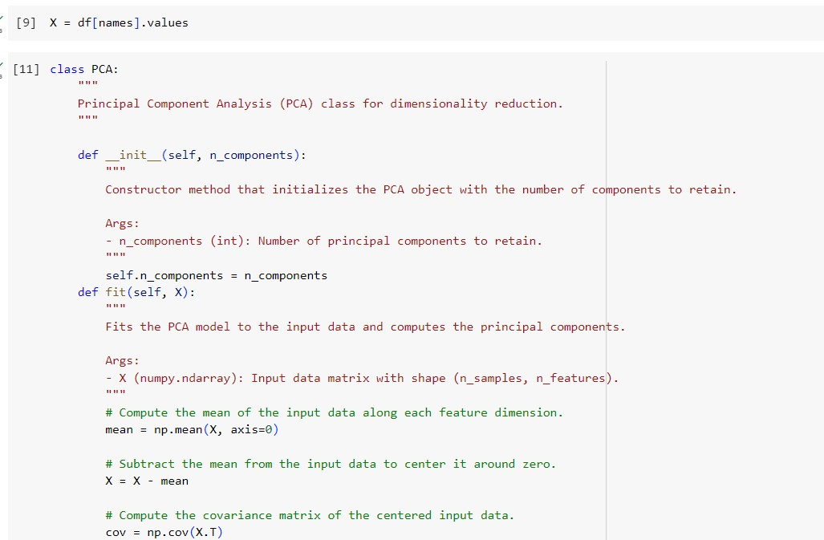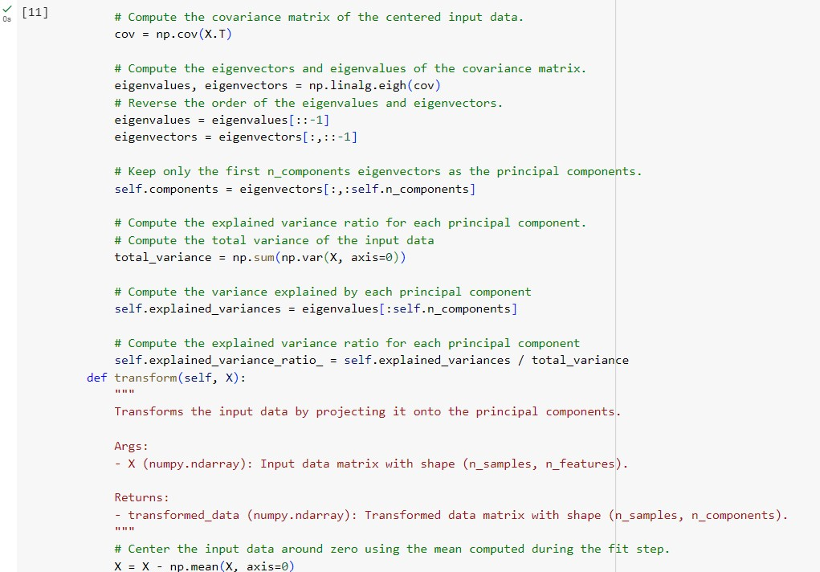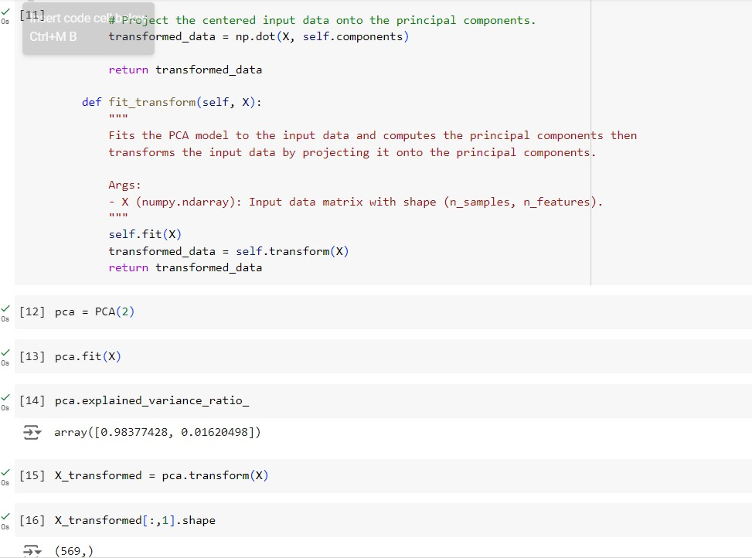

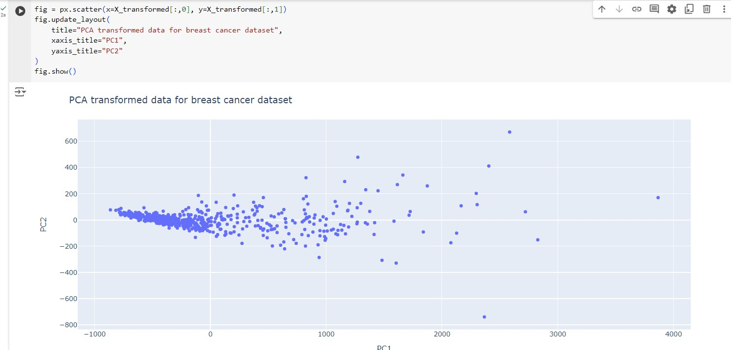

**Observation and report**

Date: 31/05/2024

Program Title: Build Artificial Neural Network model with back propagation on a given dataset

Algorithm - snapshot from observation

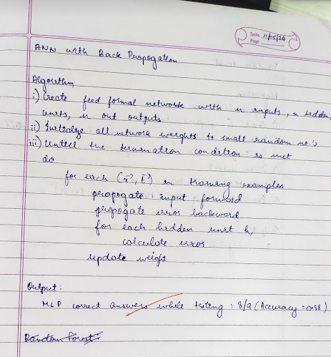

Code & Output:

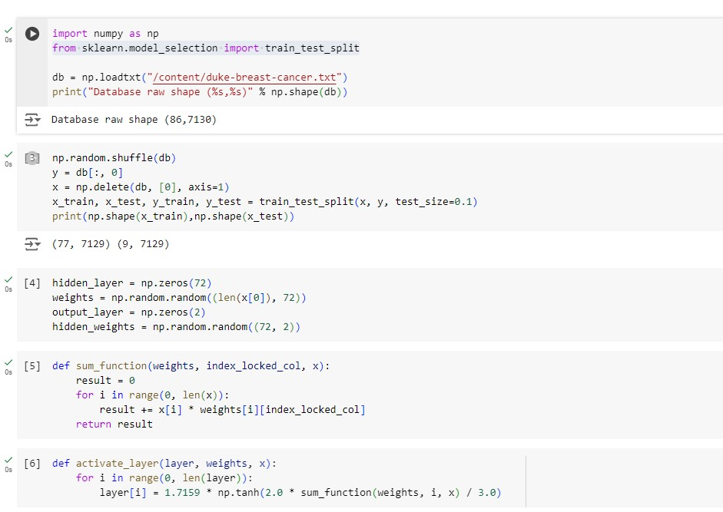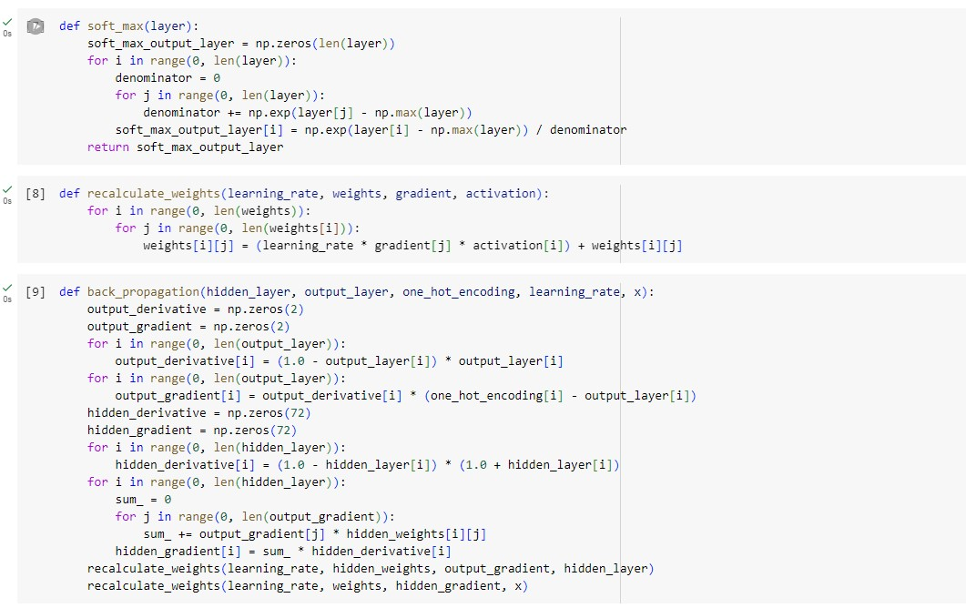

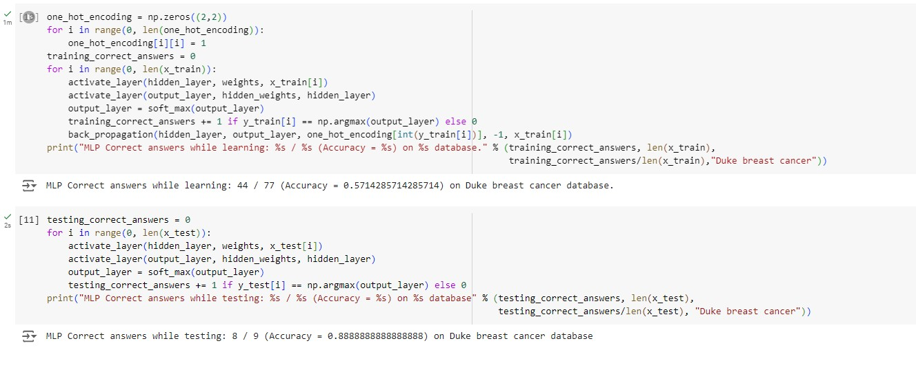

**Observation and report**

Date: 31/05/2024

Program Title: Implement Random forest ensemble method on a given dataset

Algorithm - snapshot from observation

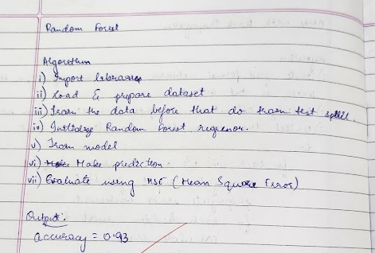

Code & Output:

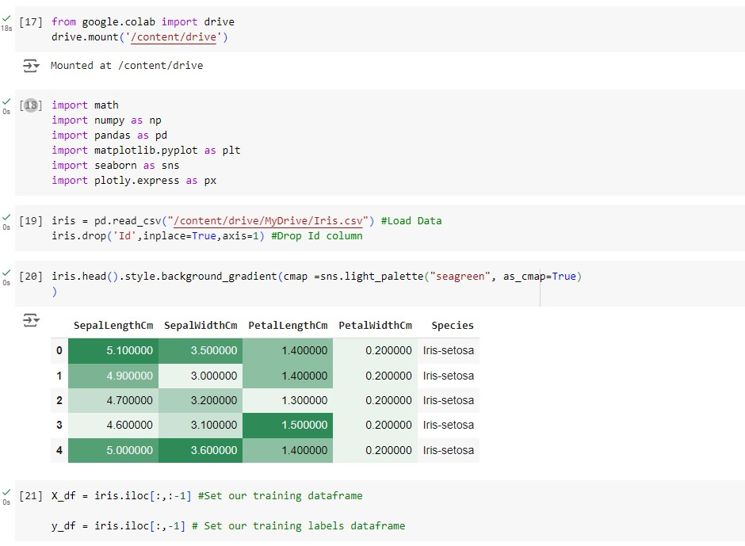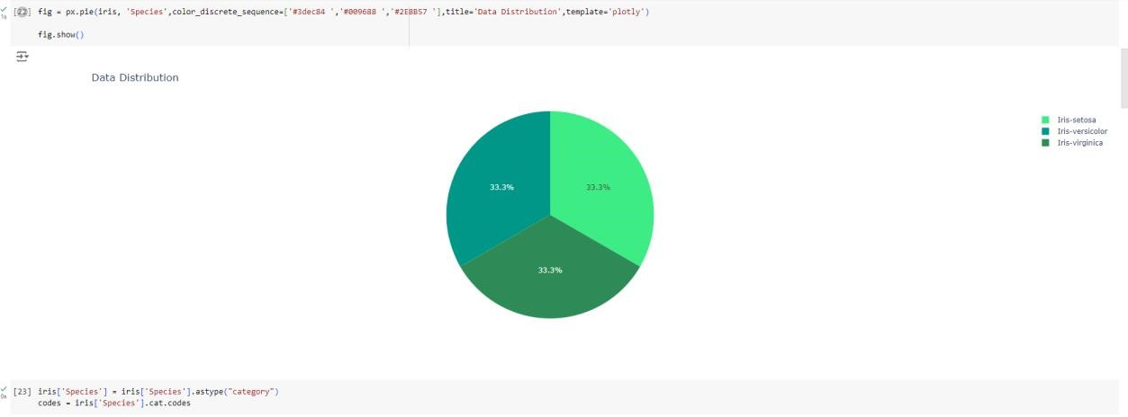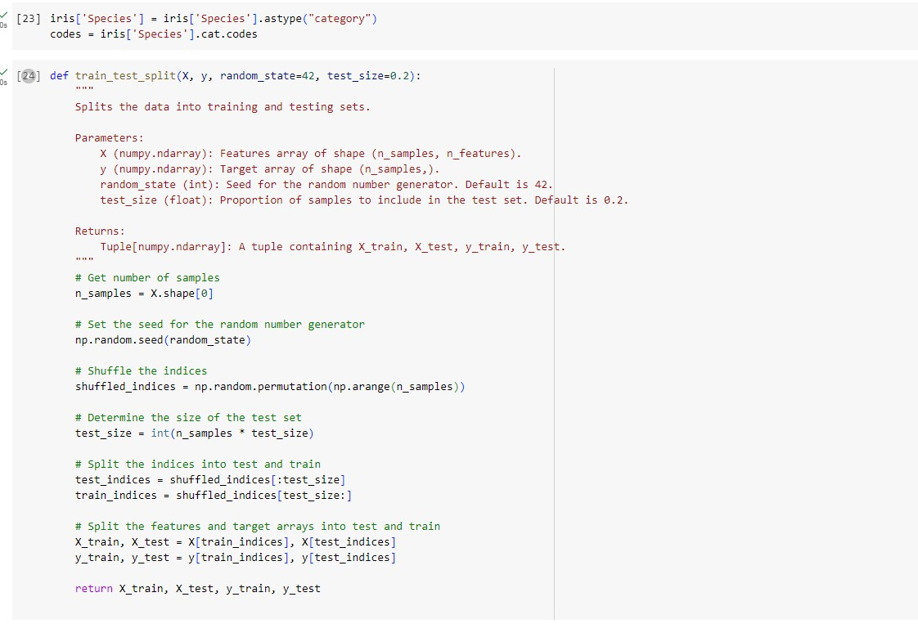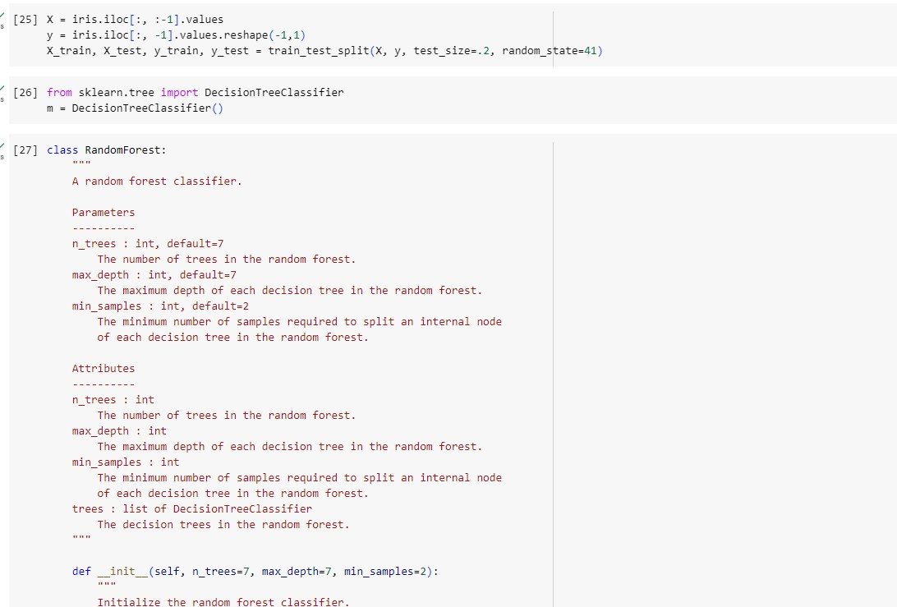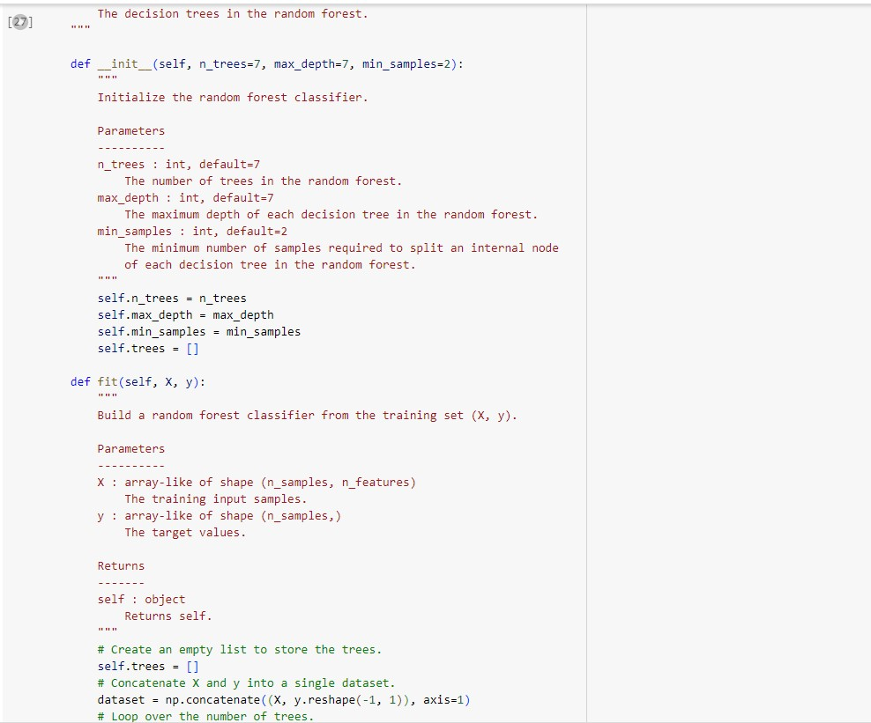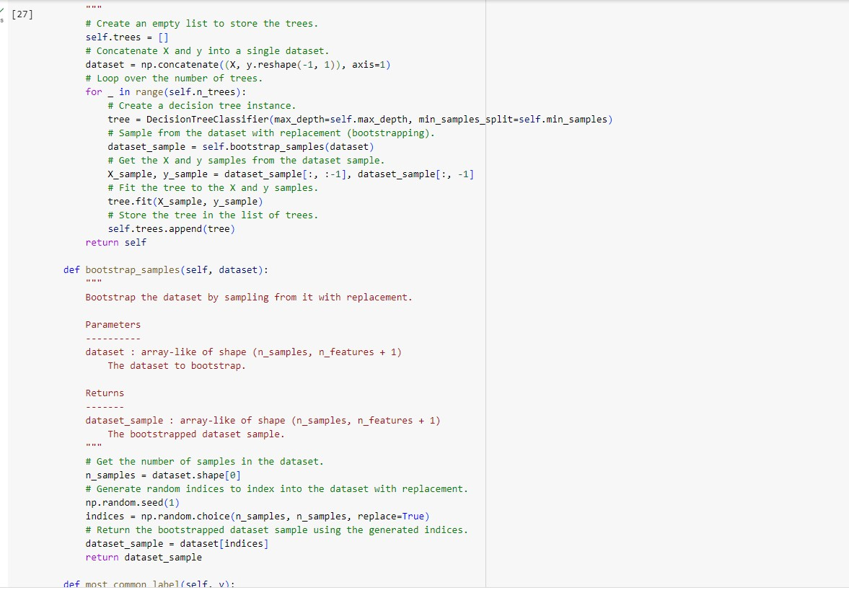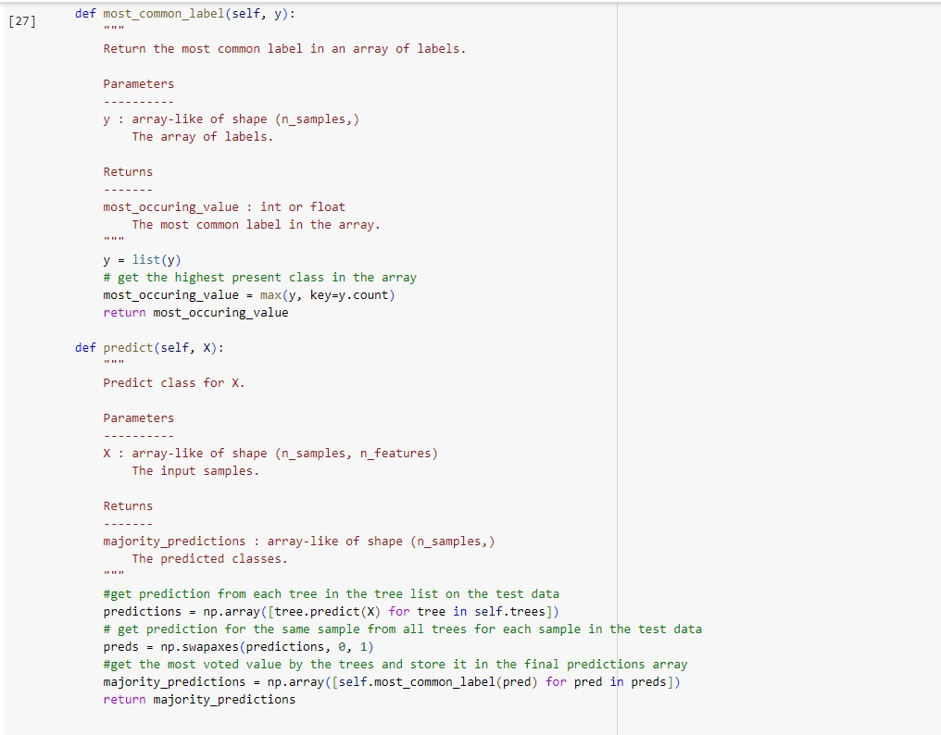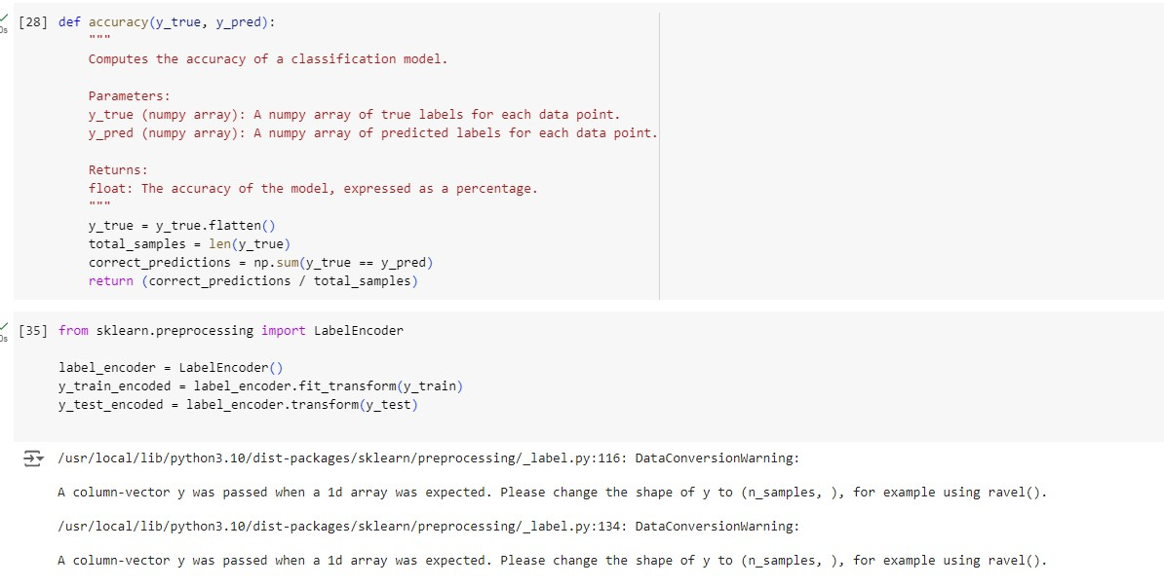

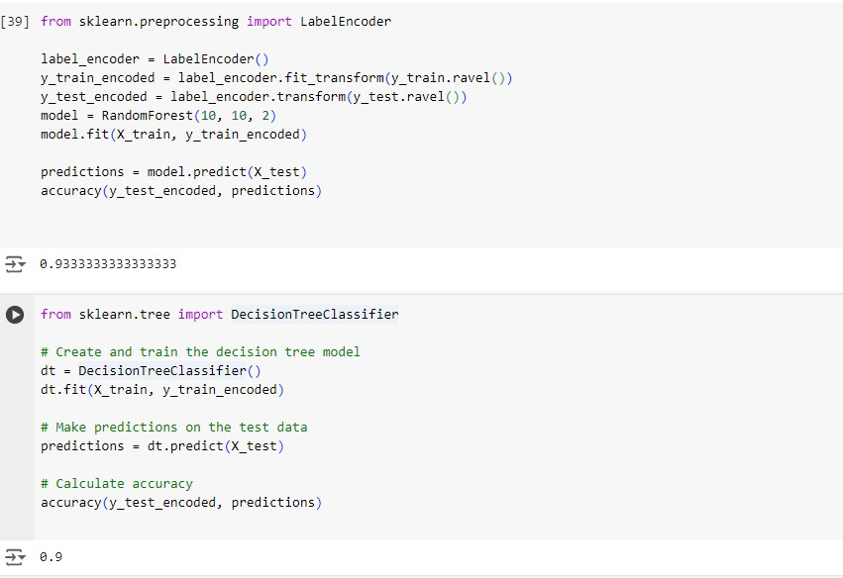

**Observation and report**

Date: 31/05/2024

Program Title: Implement Boosting ensemble method on a given dataset

Algorithm - snapshot from observation

